**A Proposal:**

**Replacing the Drinking Fountains**

**in the**

**Lizard Gulch University Student Center**

by

Tom Cruise, CEO

Water Works Experts, Inc.

**A Proposal:**

**Replacing the Drinking Fountains**

**in the**

**Lizard Gulch University Student Center**

for

H.O Sanders, Chancellor

Lizard Gulch University Student Center

by

Tom Cruise, CEO

Waterworks Experts, Inc.

January 19, 2019



***Water Works Expert, Inc.***

***Water Solutions Specialists***

***6000 Broadway, Suite #822***

***Seattle, WA 98104***

***Phone: (206) 322-6565***

January 19, 2019

Ms. H.O Sanders,

Chancellor

Lizard Gulch University

10200 Biscayne Blvd,

Lizard Gulch, California 85013

Dear Ms. Sanders:

Attached is a proposal from our company to replace the drinking water fountains in Student Center at Lizard Gulch University. You will find that this proposal is comprehensive, inexpensive, and it’s in compliance with the American Act Compliance and Americans with Disability Act.

Our company has been in business for a long time. We have the skill, expertise, and equipment to deal with any problem that can arise in this business. You may wish to check with any of the clients we have served in the past; a list of references is provided in Appendix B of the proposal.

The problem with the outdated drinking water fountains that the university currently has can be fixed once and for all. You will be delighted with the dual drinking water fountain that provides the ability to fill out water bottles and allow students to drink directly from the fountain as well. You will also find that our people are easy to deal with.

We are happy to respond to your request for proposal and have found our work in this area challenging but satisfying. We are confident that our proposal is the best that will be presented and urge your early acceptance of it.

Sincerely,



Tom Cruise, CEO

ii

**TABLE OF CONTENTS**

**Page**

LETTER OF TRANSMITTAL ii

ABSTRACT iv

INTRODUCTION 1

Background and Need 1

Purpose of Proposal 3

Benefits 3

Qualifications of Personnel 3

Data Sources 5

Scope and Limitations 5

PROPOSED PLAN 7

Methods 7

Timetable 10

Materials and Equipment 10

Personnel 11

Facilities 11

Cost 11

Expected Results 12

Feasibility 12

CONCLUSION 12

APPENDIXES 13

Appendix A. Technical Specifications 13

Appendix B. List of Clients 15

Appendix C. Complete Cost Summary 16

Appendix D. Sample Article 17

ABSTRACT

The LGU Student Center has been unable to keep up with the clean water demands of the students and staff need in the facility. Consequently, major problems in the academic environment have occurred. These problems include the possible exposure of Legionnaire’s diseases caused by the lack of proper clean filtered water available in the student center. If the problem is not solved, the university could be faced with an epidemic health problem.

The plan for replacing out-of-date drinking water fountains calls for the use of a new product the Elkay EZH2O Bottle Filling Station & Versatile Bi-Level ADA Cooler, an innovated top of the line drinking water fountain. This modern water fountain not only provides immediate thirst relief with a bottle filling station, but it contains a cooler to keep the water cold and refreshing at all times. The process of removing the existing equipment, cleaning, preparing the locations for installation of the new drinking water fountains requires approximately 20 days and a modest cost of $20,600.00. The student center will be fully operational for this process since our team can work after business hours and weekends when the student center is closed. The solution to the problem would be accomplished through a sophisticated, phase driven, and well tested process, including water testing, staff training, and a most wonderful celebration of completion to introduce the students to the drinking water fountains.

Water Works Experts, Inc. urges thorough but rapid study and acceptance of this proposal so that this critical and dangerous situation can be quickly alleviated; additionally, new inflation prices are expected to be set soon– timely response can be very cost effective.

iv

INTRODUCTION

**Background and Need**

For the past five years, the LGU (*Lizard Gulch University*) Student Center has been unable to keep up with the student demand for water fountains. This inability has caused students to be late for class, spend time in line waiting for their peers to finish drinking water or filling out water bottles. Some students have resourced to not very sanitary options such as getting water from the restroom’s sinks. If the problem is not solved, students will source to other unhealthy choices to stay hydrated such as drinking more soft drinks and energy drinks which will cause an extra expense that many students cannot afford. Students resourcing to unsanitary options can become very sick due to drinking unsanitary water, making other students sick and cause an epidemic within the university.

Additionally, some of the drinking fountains have stopped working causing even more problems. These malfunctions or shortage of drinking water fountains have a focus on the following issues:

•*Demand:* The present drinking water fountains are not enough to supply water to

increased number of students that now the university has compared to the number of

students it had when the water fountains were first installed.

•*Repairs:* The present drinking water fountains are outdated and the cost to repair them

has increased in parts due to the need to special order parts that no longer in production

and therefore, the time to repair them is long due to the wait for the shipment of the parts and the fact that there is now only one repairperson that has experience with this drinking water fountain model.

•*Safety:* Health issues are a big concern for the students that may resource to drinking

water from bathroom sinks. So far there has been one report that student contracted

Legionnaires’ disease possibly from drinking water from a restroom sink. Even though t

his event is still under investigation, the university should not take any risks on more

students getting sick as if this disease is not treated it is a life threatening.

The situation grows worse each day because students are not able to have access to drinkable water to stay hydrated in such a hot environment where the university is located at. Students are not able to perform well in their studies and classes. The situation calls for an effective solution which will eliminate all these problems, so that the LGU Student Center can once again provide quality drinking water to its students.

Figures 1 and 2 on the following page exemplify the seriousness of the situation.

*Figure 1.* Sample of an outdated drinking water fountain in the LGU student center.

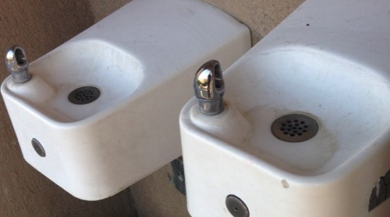

*Figure 2:* Thirsty students waiting on line to get water at the LGU Student Center

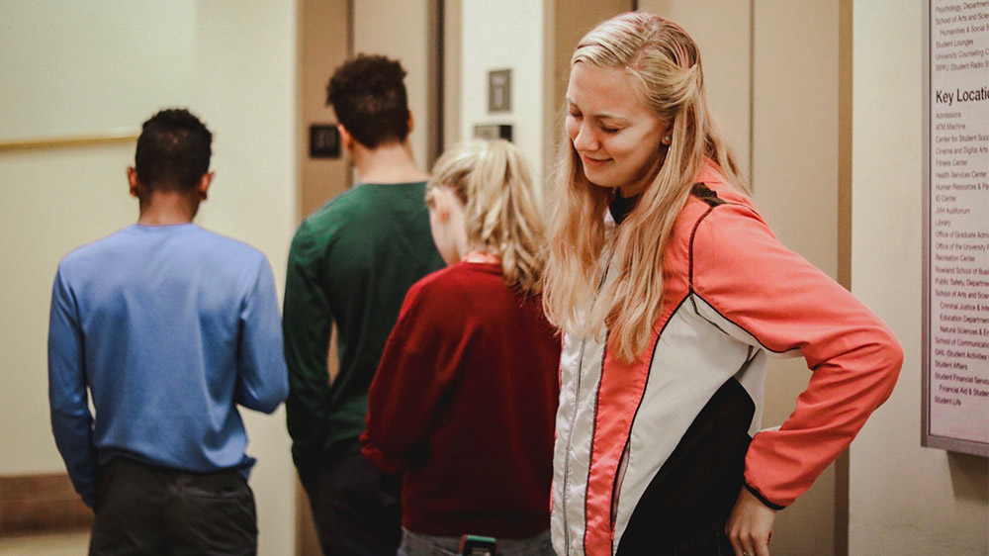

**Purpose of Proposal**

The purpose of this proposal is to replace the outdated, malfunctioning, deteriorated, and decayed drinking water fountains at the LGU Student Center with new top of the line:

Elkay EZH2O Bottle Filling Station & Versatile Bi-Level ADA Cooler, High Efficiency Filtered 8 GPH Light Gray *LZSTLG8WSLK*

*Figure 3:* Elkay EZH2O Bottle Filling Station & Versatile Bi-Level ADA Cooler

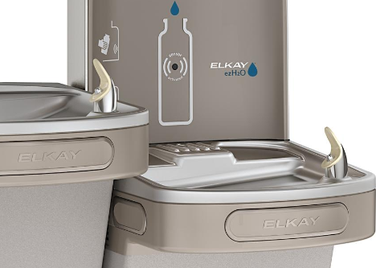

**Benefits**

If the *Elkay EZH2O Bottle Filling Station & Versatile Bi-Level ADA Cooler*  is installed to replace the current outmoded drinking water fountains, the following improvements will be observed. The new dual drinking stations will:

•Reduce the students waiting time in line 0 to 20% compared to the current wait time.

•Allow students to be able to fill their own water bottles out very quickly without holding back other students.

•Provide the LGU Student Center high quality clean filtered water to students and staff.

**Qualifications of Personnel**

The Water Works Experts, Inc. Company has been in business for over fifty years and is currently providing high quality water products all over the nation. Our central office is located

in Seattle, Washington with distribution warehouses in Los Angeles, CA., Chicago, IL and

Miami, FL. The company has a staff of 4 region managers, 50 technicians and 20 support staff. Our staff has successfully provided water solutions to both residential and corporate customers. Some of our clientele include households with large family members, elementary schools both private and public, other universities and multiple large shopping malls in Florida and California.

The executive management of our staff includes the following:

*F. Stone,* Chief Executive Officer

•Experience design of water products

•Leadership management experience for over 20 years

•Graduated from University of Alaska Anchorage

•Works diligently until tasks are completed



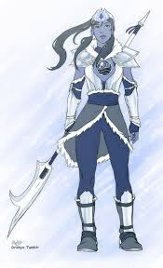

*Sophia Breeze,* Los Angeles, CA, Region Manager

•Experience includes working with Southern Water Tribe

•Got high water bending marks in college; graduated from *South*

*Water Tribe University*

• Great leadership experience with tribal group and integration

•Always works with the toughest challenges and doesn’t stop

until they are completed

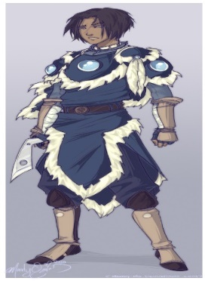

*Joshua Sokka,* Chicago IL, Region Manager

•Experience working with both North and South regions

•Graduated Summa Cum Laude from the University of Chicago

•Provides easy installation solutions to the most difficult

locations with his background in engineering and design.



*Jonathan Rivero,* Miami, FL, Region Manager

•Experience working with the most versatile water equipment

•Graduated from the University of Miami

•Provides and designs adjustments to our products for high

energy efficiency and speed.

**Data Sources**

The literature and other research related to drinking water fountains has been thoroughly investigated. Our company prides itself on being up to date in water services. The staff attends annual conferences and seminars on the latest methods for water treatments and cooling solutions to implement them into our Elkay custom design of drinking water fountains. Some of the sources used include:

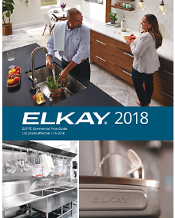

•*Elkay Custom Design 2018 Guide*: A yearly catalog with the newest and more updated designs for corporations and residential services.

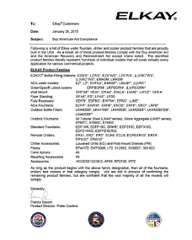

•*Seminars and Monthly Conferences.* A list of various seminars and monthly conferences is provided to all of our employees to attend and bring updates to stay in compliance with the American Act Compliance Drinking Water Solutions, which is available on our website to be accessed at any time to both our current customers and future prospects.

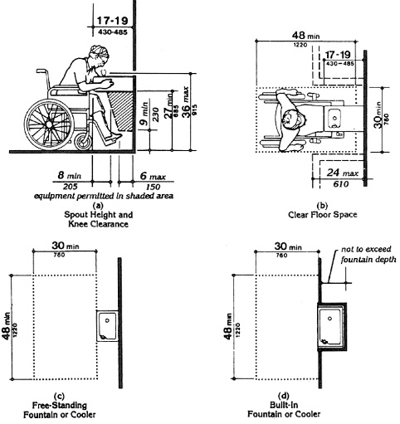

•*ADA.org*: Our staff attends annual seminars hosted by the Americans with Disabilities Act division to make sure our products serve people with disabilities and designs and installations are adjusted to serve the needs of special needs people.

**Scope and Limitations**

The following proposal is limited only to LGU Student Center. These materials are to be considered confidential and sensitive. It is not intended to be adapted to any other private or public university. The proposal is limited by the special time related conditions that prevail. Any persons, living or dead, connected with this proposal are under contract to the Water Works Experts, Inc. and are not authorized to provide information to any other agency or disclose the negotiated rates provided.

[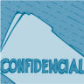](http://images.google.com/imgres?imgurl=www.health.org/govpubs/workits/confidential.gif&imgrefurl=http://www.health.org/govpubs/workits/tip3.htm&h=181&w=181&prev=/images?q=confidential&svnum=10&hl=en&lr=&ie=UTF-8&oe=UTF-8&sa=G)

This proposal is the property of the Water Works Experts, Inc. and it cannot be reproduced, distributed, copied, or rebroadcast without the express written consent of the President of the company and its in-house attorney. A specific list of the limitations and specifications is found in Appendix B

**PROPOSED PLAN**

The following plan provides information for the replacement of the current drinking water fountains at the LGU Student Center with the Elkay EZH2O Bottle Filling Station & Versatile Bi-Level ADA Coolers. The plan is designed to be comprehensive while retaining a simple format for ease of understanding. Additional technical details will be provided upon request. The plan deals with all contingencies that might occur.

**Methods**

The major methods to be employed deal with the following areas:

•Removal of the current

•Preparation of the facilities for installation of the Elkay EZH2O Bottle Filling Station &

Versatile Bi-Level ADA Coolers

•Installation of the Elkay EZH2O Bottle Filling Station & Versatile Bi-Level ADA

Coolers

•LGU staff training on using and little maintenance of the Elkay EZH2O Bottle Filling

Station & Versatile Bi-Level ADA Coolers

•Testing of the Elkay EZH2O Bottle Filling Station & Versatile Bi-Level ADA Coolers

*Phase 1: Removal of the current drinking water fountains:*

1. Equipment maintenance specialist will come to the Student Center after business hours or

during the weekend to remove the outdated drinking water fountains. A cleaning crew will be on standby to clean in a safe manner any debris that may come off from the removal and sanitize any contamination that may have been built up from the old equipment.

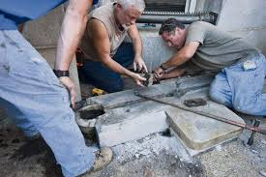 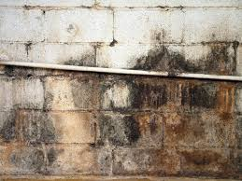 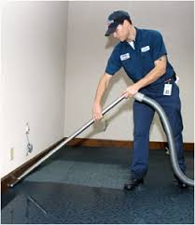

2. Equipment delivery will happen as soon as our cleaning crew are done. The delivery crew will unpack and make ready the equipment to make sure the placement of the new water fountains happens quickly and efficiently.

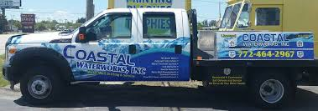 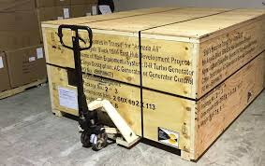 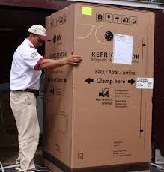

3. The engineering team will evaluate and check plants to ensure proper mounting of the fountains. Detailed measurements will taking place to prevent any future malfunctions.

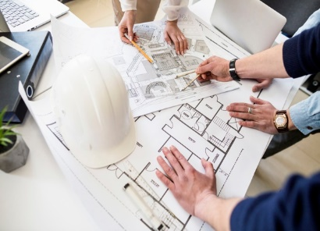  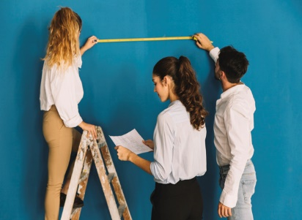

*Phase 2: Wall mounting and installation of Elkay EZH2O Bottle Filling Station & Versatile Bi-Level ADA Cooler.*

The mounting and installation of the new water fountains will be performed by our installation crew. Each member is well trained to handle the different components involved in this phase.

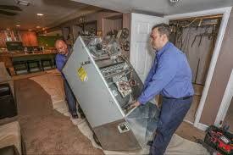 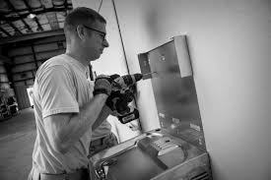 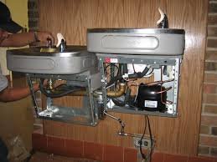

*Phase 3: Water Testing of Elkay EZH2O Bottle Filling Station & Versatile Bi-Level ADA Coolers.*

After completing installation and mounting, we will have our crew collect water samples of each fountain installed to make sure the quality of the water is the best for the LGU Students and staff.

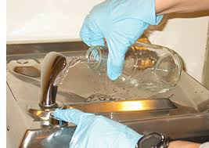 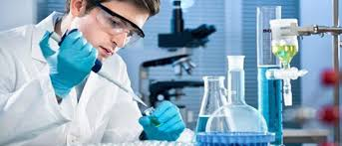 

*Phase 4: LGU Staff training on using the Elkay EZH2O Bottle Filling Station & Versatile Bi-Level ADA Coolers.*

LGU staff will be trained on the easy use and resetting of the new *Elkay EZH2O Bottle Filling Station & Versatile Bi-Level ADA Coolers.* The staff will be trained to do very easy basic maintenance such as resetting if ever needed and water temperatures adjustments if necessary.

 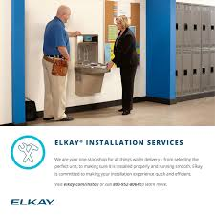

*Phase 5: Introducing the* *Elkay EZH2O Bottle Filling Station & Versatile Bi-Level ADA Coolers to the school.*

We will introduce the new drinking water fountains to the students with a small celebration.

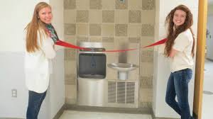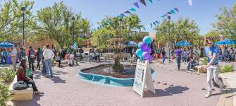

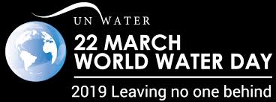

**Timetable**

It takes approximately 20 business days from the time the proposal is accepted have the new drinking water fountains installed and fully operational. The following complete timetable specifies the stages of each process. Although the actual installation time is short, the time required for obtaining the parts and equipment to be ordered and received will take some time.

**Activity** **Completion Date**

Removal of current water drinking fountains Day 15

Preparation of facility for installation Day 16

Installation of new *Elkay EZH2O* fountains Day 17

LGU staff training on new fountains Day 18

Water testing and lab results Day 19

New Fountains Ceremony Day 20

**Materials and Equipment**

The following materials will be needed:

500 feet Blue PEX Pipe

10 GFCI Electrical Outlets

5 Water Supply Connectors

100 3 inch Screws with Anchor Walls

20 feet PVC Pipe

5 Filters

5 Power Surges

5 Gallons Clorox

The following equipment will be needed:

Delivery Pick Up-Trucks 2

Hot Water Pressure Washers 2

Electrical Drills 5

Electrical Screw Drivers 5

Levels 3

Garage Dolly 2

**Personnel**

The following personnel are required to implement this proposal:

* Removal of Equipment Crew (5) for 2 days
* Cleaning Custodians (3) for 5 days
* Engineer Location Specialists (3) for 3 days
* Delivery Team (4) for 1 day
* Installation Specialists (5) for 3 days
* Training Expert (1) for 1day
* Event Coordinator (1) for 2 days

**Facilities**

The LGU Student Center will need to be available for our personnel for 4 days in order for the removal of old equipment, cleaning, preparation and installation of the new equipment to occur.

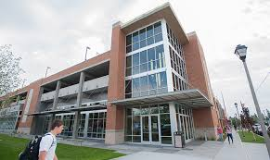 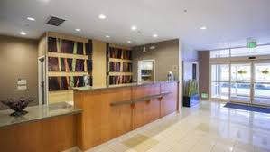

**Cost**

The summary cost breakdown for this project is as follows (a complete cost summary is found in Appendix C:

•Materials as listed above $ 500.00

•Equipment purchase $ 7,500.00

•Overall labor . $ 9,600.00

•Management oversight $ 3,000.00

**Total** **$20,600.00**

**Expected Results**

When the *Elkay EZH2O Bottle Filling Station & Versatile Bi-Level ADA Coolers* are installed the following results should be observable:

* Health risks due to water contamination will be greatly reduced.
* Clean fresh water will be available to all the students and staff at the LGU Student Center.
* Personal water bottles will be able to be refilled at no cost to staff and students.
* Students will be properly hydrated and therefore will have more energy for their studies.
* There will no longer be long lines of students and staff waiting to get water.
* The student center will have a clean modern clean look due to the new updated drinking water fountains.

**Feasibility**

This project can be accomplished, but only Water Works Experts, Inc. can do it in a timely manner. Only our company has the experience, the expertise, and low cost to make this project successful. Also, only our company has direct access to all the major manufactures with private contracts to provide an unbeatable price to our customers. No other company would be able to accomplish this task since they do not have the appropriate resources. This is a demanding and exciting project that only our company can do it. If the *Elkay EZH2O Bottle Filling Station & Versatile Bi-Level ADA Coolers* do not perform at the promised and exemplary level described within, can be removed within 10 days and all payments will be refunded within a 60 day period.

**CONCLUSION**

The preceding proposal is one that is:

•Well researched

•Proven over six months

•Feasible

•Cost effective

Most of all, the proposal meets the expressed and critical needs of the LGU Student Center and will allow it to serve its students in a healthy manner.

For these reasons, it is requested that this proposal be accepted immediately so that the project can move forward without delay. It might also be noted that the cost for the installation is based on our 2017 prices so the cost can be more economical if the decision to move ahead is made quickly.

**Appendix A:** Technical Specifications of the Elkay EZH2O Bottle Filling Station & Versatile Bi-Level ADA Coolers.

Specifications

|  |  |
| --- | --- |
| **Installation Location** | INDOOR |
| **Number of Stations** | One (1) bottle filling station and one (1) drinking fountain |
| **Mount** | Wall mount, surface mount |
| **Basin** | Stainless Steel, Brushed |
| **Cabinet** | Light Gray Granite Vinyl Clad Steel |
| **Bubbler** | FlexiGuard StreamSaver |
| **Cooled ?** | Yes |
| **Chilling Capacity** | 8 GPH (Gallons per Hour) |
| **Filtered ?** | Yes |
| **Power** | 115V/60Hz (Plugs into wall outlet. 3 Prong standard plug included) |
| **Status Display** | LCD Green Ticker Bottle Counter |
| **Product Dimensions** | 35-5/8" Tall x 19" Wide x 19" Deep |
| **Net Weight** | 68 |
| **Shipping Dimensions** | 33" Height x 24" Width x 24" Length |
| **Shipping Weight** | 71 |
| **Product Compliance** | ADA & ICC A117.1 ASME A112.19.3/CSA B45.4 Buy American Act CAN/CSA C22.2 No. 120 GreenSpec NSF 61 NSF 372 (lead free) UL 399 |

Downloadable Resources

|  |
| --- |
| Download the [**specifications sheet for the LZSG8WSLK**](https://www.restroomdirect.com/pdf/Elkay/Elkay_LZSG8WSLK_LZSG8WSSK_Spec_Sheet.pdf) |
| Download the [**owner's manual for the LZSG8WSLK**](https://www.restroomdirect.com/pdf/Elkay/Elkay_EZSG8WSLK_EZSG8WSSK_LZSG8WSLK_LZSG8WSSK_Installation_Manual.pdf) |
|  |
| Download the [Elkay Product Warranty](https://www.restroomdirect.com/pdf/Elkay/Elkay_Limited_Product_Warranty.pdf) |

Additional Information

|  |
| --- |
| [How to reset filter status monitor on EZH2O Bottle Filling Stations](https://www.restroomdirect.com/pdf/Elkay/EZH2O_Filter_Reset_Instructions_(Non-Enhanced).pdf)  (Read this one first) |
| [How to program settings on EZH2O Bottle Filling Stations](https://www.restroomdirect.com/pdf/Elkay/Elkay_EZH2O_Programming_Instructions_(Non-Enhanced%20Version).pdf) |

|  |
| --- |
| **FILTER** |
| The Elkay® WaterSentry® Plus is certified by WQA to NSF/ANSI Standard 42 and 53 for the reduction of Aesthetic Chlorine, Taste and Odor, Particulate Class I, and Lead, as verified and substantiated by test data. |
| **ADA COMPLIANT** |
| These Water Coolers comply with the requirements of A.D.A. (Americans with Disabilities Act) when properly installed. Also meets the guidelines for children’s environments providing the floor to orifice height is 30" or less and proper clear floor space is provided for parallel approach. (Based on Architectural and Transportation Barriers Compliance Board final ruling.) Check Local and State Codes. |
| **NO LEAD DESIGN** |
| These Water Coolers are certified to be lead-free as defined by the Safe Drinking Water Act. Elkay Water Coolers are manufactured with a waterway system utilizing copper components and completely lead-free materials. These waterways have no lead because all lead materials, such as leaded brass, have been removed. All joints are brazed using silver solder only. No lead solder is permitted. A strainer with an easily cleanable screen is provided to allow trapping and convenient removal of waterborne particulate of 140 microns and larger prior to their entry into the water cooler. |
| **CONSTRUCTION** |
| **Frame:**Galvanized structural steel chassis supports refrigeration system and fastens to wall. Provides increased structural integrity and rigidity to cooler.   **Stainless Steel Basin:**One piece polished to a uniform Elkay bright luster finish. Basin has integral drain grid, embossed bubbler pad. No exposed fasteners.   **Exclusive Flexi-Guard® Safety Bubbler:**Innovative design utilizes an infused anti-microbial pliable polyester elastomer to prevent accidental mouth injuries. Flexes on impact, then returns to original position. Strong. Abrasion-resistant. Anti-sweat. Keyed in location to prevent rotation.   **Cooling Unit:**Combination tube-tank type. Self cleansing. Tube portion is continuous coil of copper tubing. Tank is stainless steel. Fully insulated with EPS foam which meets Underwriters Laboratories Inc. requirements for self-extinguishing material. Refrigerant Control: Refrigerant HFC-134a is controlled by accurately calibrated capillary tube for positively trouble-free operation.   **Temperature Control:**Enclosed adjustable thermostat is factory pre-set. Requires no adjustment other than for altitude requirements. Easily accessible. |

**Appendix B:** Partial List of Clients

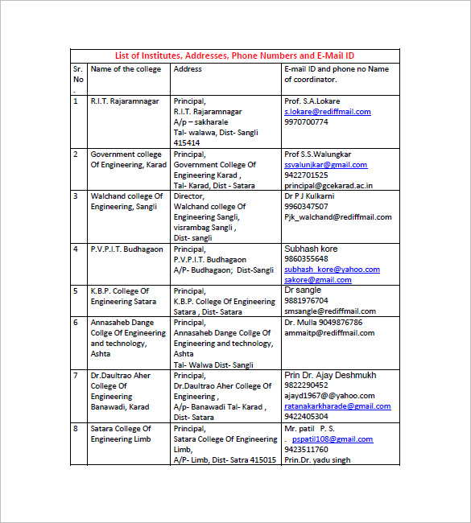

**Appendix C:** Complete Cost Summary

**1. Facts & Assumption**

|  |  |  |
| --- | --- | --- |
| Invoice amount | $20,600.00 |  |
| Term | Net 30 days |  |
| Collection | 30 days |  |
|  |  |  |

**2. Cost Calculation**

*Elkay EZH2O Bottle Filling Station & Versatile Bi-Level ADA Coolers* 5 x 1400.00 $ 7,000.00

Miscellaneous Materials (screws, wall mesh, cement, etc) 1 x 500.00 $ 500.00

Delivery Fee 1 x 500.00 $ 500.00

Removal of Equipment Crew 5 x 550.00 $ 2750.00

Cleaning Custodians 3 x 550.00 $ 1500.00

Engineer Location Specialists 3 x 1000.00 $ 3000.00

Delivery Team 4 x 375.00 $ 1500.00

Installation Specialists 5 x 550.00 $ 2750.00

Training Expert 1 x 500.00 $ 500.00

Event Coordinator 1 x 600.00 $ 600.00

**Total Costs 20,600.00**

**3. Payment from Client**

|  |  |  |  |
| --- | --- | --- | --- |
| At the time of Proposal Acceptance | $10,000 Deposit Fee | $ 10,000.00 |  |
| At the End of Training | $10,600 Remaining Fee | $ 10,600.00 |  |
|  |  | --------------- |  |
| Disbursement total |  | **$ 20,600.00** |

Factoring all charges will be made to client account at the time of actual occurrence in the form of advances. If you do not use advance service, however, charges will be made at the time of collection of the invoices.

**Appendix D:** Sample Article:

Posted on September 06 2018

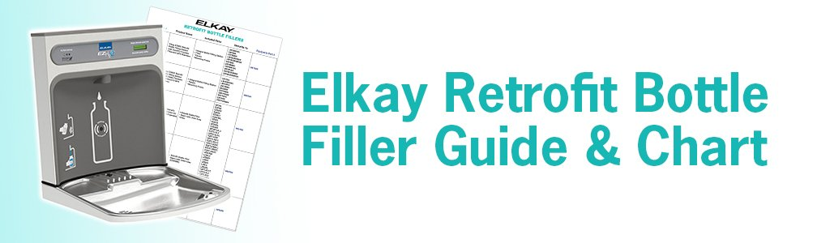

This article is written for facility and purchasing managers who currently have Elkay drinking fountains and/or water coolers installed throughout their facility, and want to convert them into combination bottle filling stations. Elkay drinking fountains and water coolers can be retrofitted with a simple add-on installation. In this article, you will learn which Elkay water cooler and drinking fountain models can be retrofitted and which cannot, the benefits of retrofitting your water fountains, and the most common questions that Elkay and Equiparts customer service representatives get about retrofitting Elkay water coolers and fountains.

First of all, kudos to you for helping your visitors stay hydrated and reduce plastic waste! And cheers to your business or organization for empowering you to make a positive impact on your facility!

Retrofitting water fountains into bottle filler combination units can seem like a big, complicated project. It’s not. In fact, at Equiparts, we do everything we can to make retrofitting your drinking stations easy. First, we recommend using the chart below to find out if your Elkay unit can be retrofit. You will most likely need to replace your units with new, combination bottle filler drinking fountain units, unless you want to simply add a glass filler attachment, which might be possible for some units (call us for more information on glass filler attachments). Click on the link to view our selection of [bottle filling stations](https://equipartsdrinkingfountains.com/collections/bottle-fillers). Select the retrofit kit that is compatible with your unit in the list below the chart. Then add your retrofit kits to the cart and place your order. Once you receive your retrofit kits, give us a call for support with your Elkay drinking fountain with bottle filler installation. And voila! Your facility will be outfitted with shiny new bottle filler kits for your water coolers.

**Benefits of Bottle Filling Stations**

There are many benefits of retrofitting your facility’s drinking fountains and/or water coolers, including the following:

* **Create Versatile Drinking Options**

Drinking fountain bottle filler combination units allow users to either get a quick drink of water from the bubbler, or fill up their water bottle to keep with them during class, while they shop, or during work.

* **Showcase Environmental Actions**

Upgrading water fountains to bottle filler water fountain combination units throughout your facility is a highly visual and functional display of your facility’s commitment to preserving the environment.

* **Reduce Plastic Waste**

Bottle filling stations encourage the use of reusable water bottles over disposable water bottles. This reduces plastic water bottle sales and the amount of plastic bottles occupying our landfills.

* **Increase Hydration**

Keeping a bottle of water close by at all times makes it easier for people to drink water throughout the day and stay hydrated.   
  
View our online selection of [Bottle Filler Retrofit Kits](https://equipartsdrinkingfountains.com/collections/retrofit-bottle-fillers). If you do not see the retrofit kit you need, no worries. Give us a call. We carry more retrofit bottle filling stations than we list in our online store.

**Elkay Bottle Filler Retrofit FAQs**

Read the frequently asked questions below to find answers to common questions regarding retrofitting Elkay water coolers and drinking fountains. 

**Is retrofitting a water cooler hard?**

In general, no. Retrofit kits are sold with all of the items needed to retrofit your water cooler. The kits also include detailed instructions for installation. Equiparts and Elkay customer support by phone is also available to you during regular business hours in case you need additional help or have a specific question. 

**Are there any big mistakes I should try to avoid when it comes to retrofitting my unit?**

One mistake you don’t want to make is purchasing the wrong retrofit kit for your water cooler. This is why we have written this article for you that shows which retrofit kits are compatible with your water cooler. 

**Do bottle filler retrofit kits come with refrigeration?**

No. If you add a bottle filler kit to a non-refrigerated drinking fountain, the Elkay drinking fountain bottle filler retrofit will also be non-refrigerated, just like the water from the fountain. If you add a bottle filler kit to a refrigerated drinking fountain, then the bottle filler water will be refrigerated as well. 

**Do retrofit bottle filling stations need power?**

Yes. All bottle filling stations will need to plug into a power outlet. 

**What voltage do bottle filler retrofit kits use?**

Standard 115/120 voltage. 

**Can EBV water coolers be retrofit with bottle fillers?**

No. EBV water coolers are obsolete so there are no retrofit kits available for those units. 

**Can BFC water coolers be retrofit with bottle fillers?**

No. EBV water coolers do not have retrofit kits. 

**What type of fittings do the retrofit bottle filler kits use?**

Push fittings, which make installation easier.

### Which is harder to retrofit, a single water cooler or a bi-level water cooler?

Single is more difficult because the unit must be pressurized. This means you have to change the set up of the internal mechanisms within the unit since water will be pumped into two locations, instead of the single connection in the original configuration. Bi-level units are already pressurized because they have two connections. This will make retrofitting easier. See the image below from Elkay to see the difference between a single, non-pressurized water cooler (pictured left,) and a two connection, pressurized water cooler and bottle filler set-up (pictured right).   
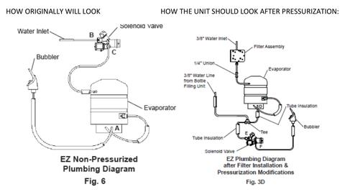 

### Don’t see the answer to your question?

No problem. Give us a call or [send us an email](mailto:info@equipartsdrinkingfountains.com) to get the help you need to retrofit your Elkay water cooler or drinking fountain. We are here to help!

Phone: Toll-Free: [800-442-6622](tel:+1800-442-6622%EF%BB%BF)  
Pittsburgh: [412-781-9100](tel:4127819100)  
Mon-Fri 7:30am – 5pm EST