Oiling the Rack

# Introduction

Weekly maintenance includes oiling the fuel rack on the main engines. Failure to maintain proper lubrication of the fuel rack could cause it to stick or freeze up causing fuel surges or starvation during operation. The governor will not be able to regulate speed in this case.

Only perform this maintenance when the engines are shut down and inform the watch engineer before beginning maintenance, so the engines are not accidentally started while you are working on them.

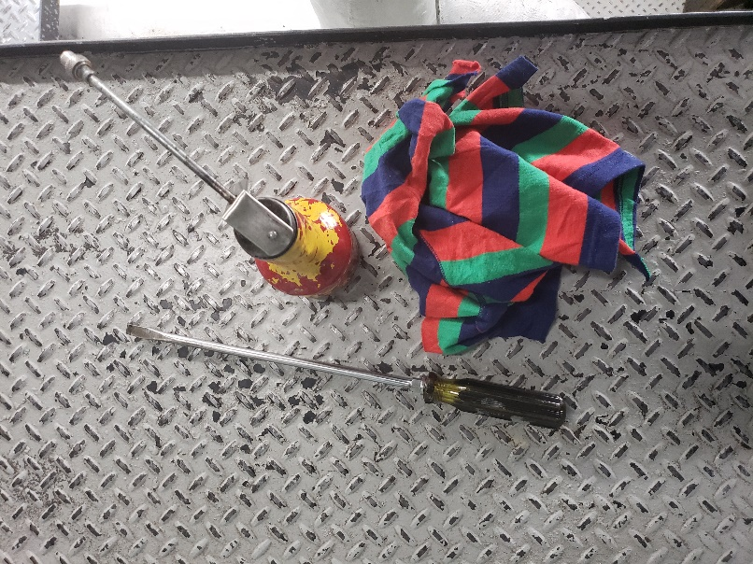Warning: Never touch the rack when the engines are running. Fingers could be pinched in machinery and you will cause the fuel rack to freeze up underway.

# Tools

* Rack oil can
* Pry bar
* Rag

(Red and orange can

labelled “RACK”)

Pry Bar from Oiler Tool Bench

Warning: Keep your tools on the catwalk behind you when moving from one section to the other. Do not keep them on the engine itself. A forgotten tool could fall into the flywheel causing massive damage to machinery and personnel. A forgotten tool on the catwalk is much less likely to fall and will be eventually found and put away.

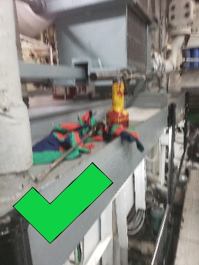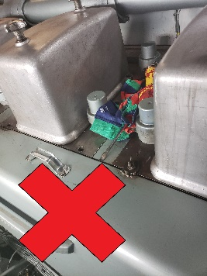

Warning: Remove items from pockets so they do not accidentally fall into engine while working on it. You don’t want to tear the whole thing apart to retrieve a pencil.

# Steps

1. Remove wing nut capped bolts from cover. Two bolts per cover. Lean against cover to secure during removal. Place each bolt in a spare hole, slightly threading it in to prevent them falling or being lost.
2. Using either the top or side handles lift and pull the cover off. There is a lip at the top of the cover that will hang on the bottom edge of the rack space. Gently lower the lip of the cover onto this ledge. Release it slowly to ensure it is balanced before removing your weight from the cover.

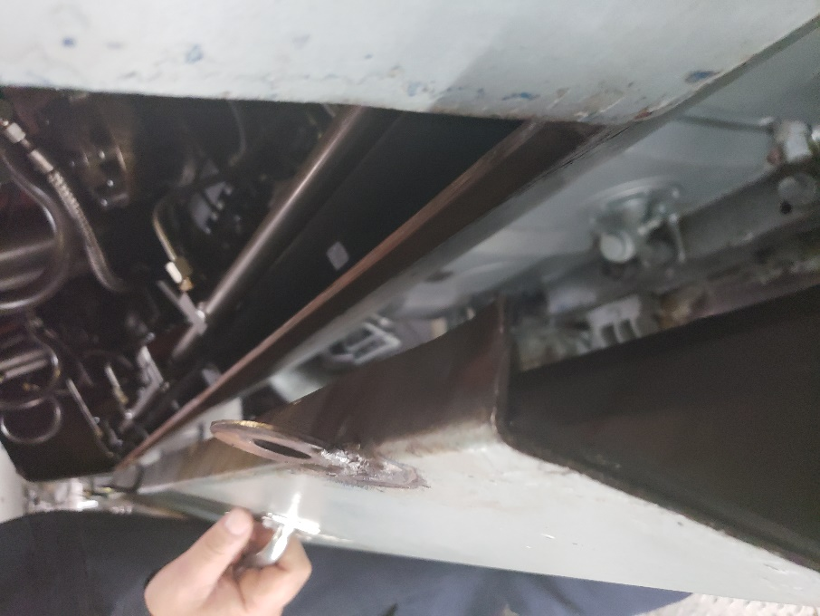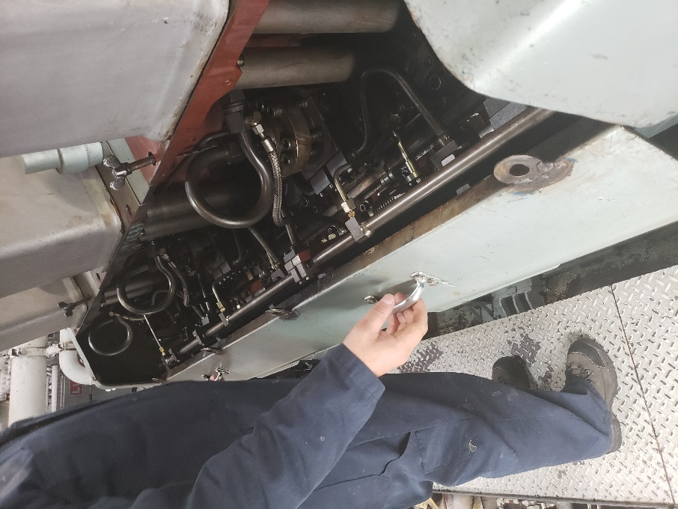

Warning: Rack covers are heavy and awkward. Be careful not to drop them or you could break a toe. Lean into the cover to hold it in place while removing or replacing the bolts and give it a shake to ensure it is securely fastened before letting go. Also, be careful not to bang the cover into the rack, causing damage to machinery.

1. Inspect the engine space for leaks, loose lines and parts, and anything else out of the ordinary. If you find anything report to the watch engineer before continuing.

Warning: Rack components will be hot. Be careful not to burn yourself.

1. Insert pry bar as shown. Use the pry bar to actuate the rack, holding it in the maximum extended position.

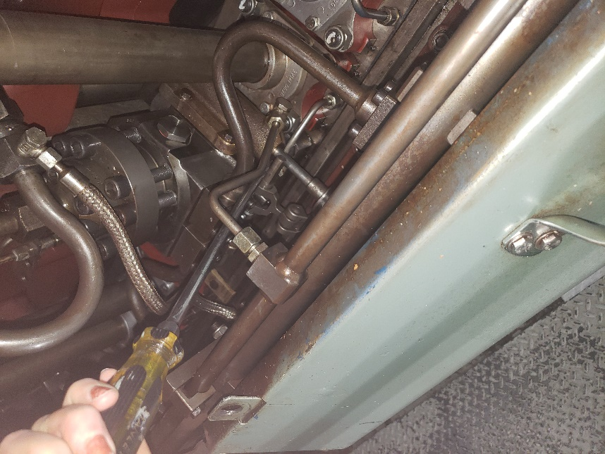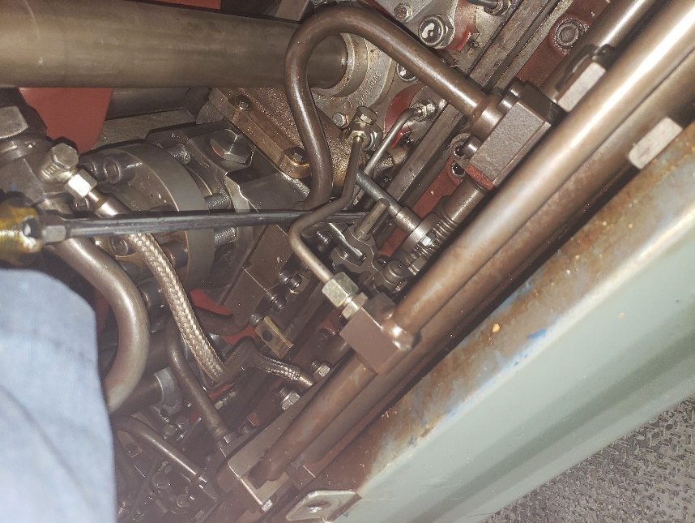

Warning: Use caution with the pry bar not to bang or scratch the machinery. This could cause damage and faulty operation.

1. Aim the nozzle of the oil can onto each joint and depress the handle of the oil can to squirt oil onto the rack. Apply a few drops of oil to each moving joint as well as the springs as illustrated below.

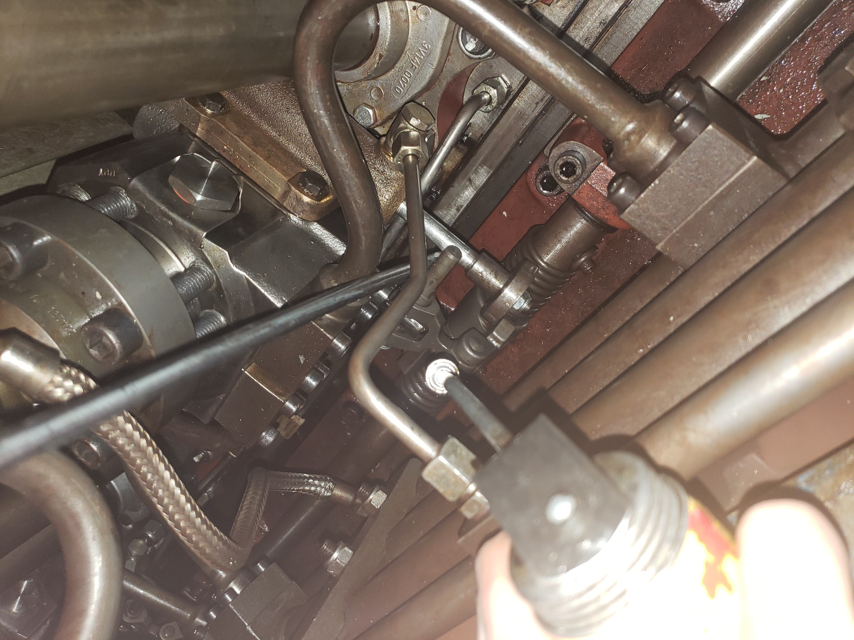

1. Move the pry bar forward and back to actuate the rack a few times to help spread the oil. Release the pressure gently. Do not allow the rack to snap back into place.
2. Move onto the next injector and repeat steps 4-6. There are 4 injectors under each cover.
3. Once each injector has been oiled replace the cover. Lift the cover by the top handles. There is a lip on the bottom of the cover that lines up with the bottom of the rack space as illustrated below. Make sure the bottom lip lines up before lining up the bolt holes.

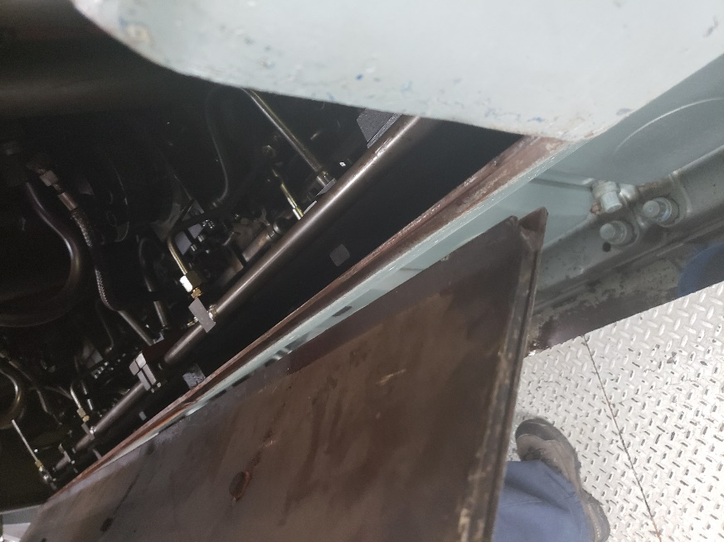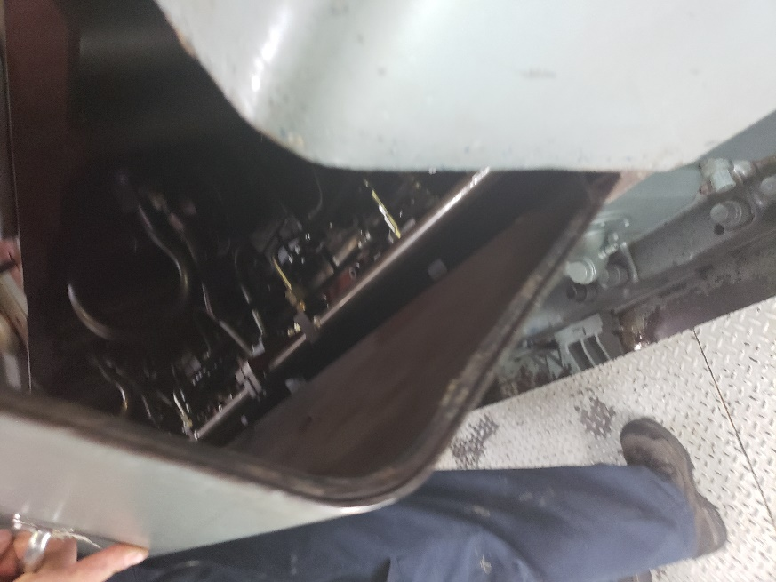

Warning: Make sure to wipe your hands of any oil before handling cover to prevent slipping or dropping it. Use only one rag and one pry bar. Be positive there are no rags or tools left behind before replacing the cover. A tool or rag left behind when the engine starts will cause massive damage to the rack.

1. Once the cover is aligned replace the wing nut capped bolts to hold the cover in place.

lean into the lid to hold it while screwing in bolts and give the cover a shake to ensure it is secure before letting go. The bolts only need to be hand tight. Do not use a wrench.

1. Move onto the next cover and repeat steps 1-9 for each section.

# Conclusion

There are two three sections on each side of the engine, six sections per engine. Do both the port and starboard engines.