***Step 1: Have the appropriate safety gear.***

* Wear elbow pads and knee pads.

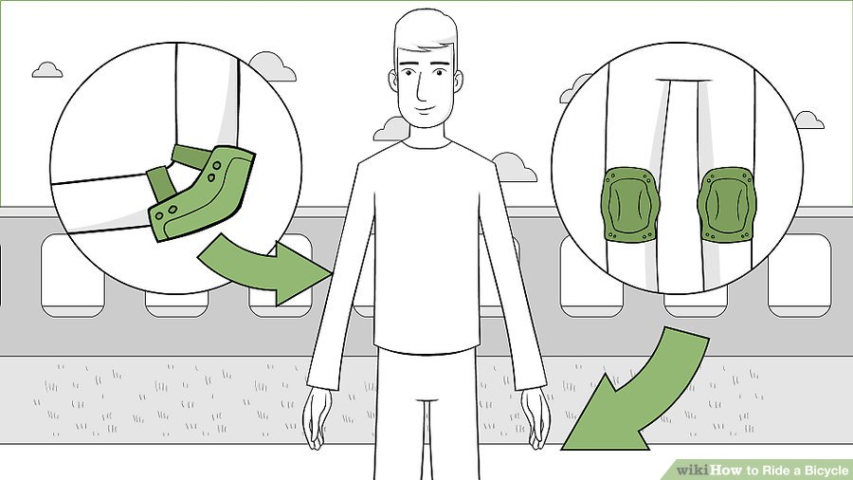

* Wear a helmet

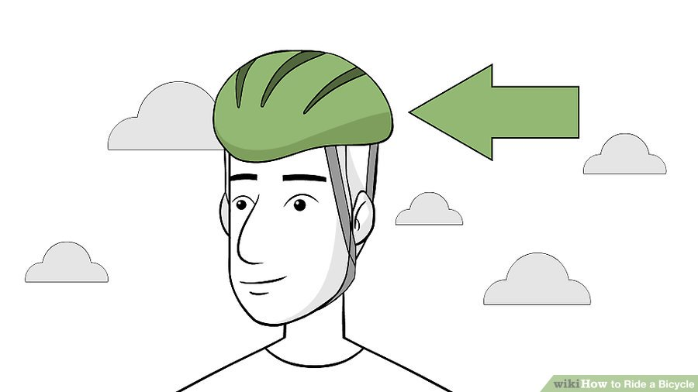

***Step 2: Go out in the daytime***

 



***Step 3: Choose appropriate terrain***

* Paved sidewalks/trails are your friend

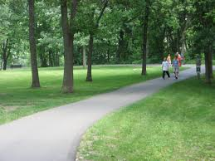

* Avoid dirt trails with lots of rocks and tree roots

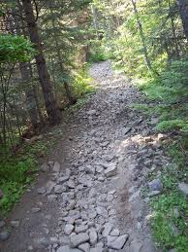



***Step 4: Put on Rollerblades***

* Remember to securely fasten all straps

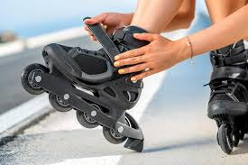

***Step 5: Have Fun***