Removing a Front Tire on a Quick-Release Bicycle with Presta Valves

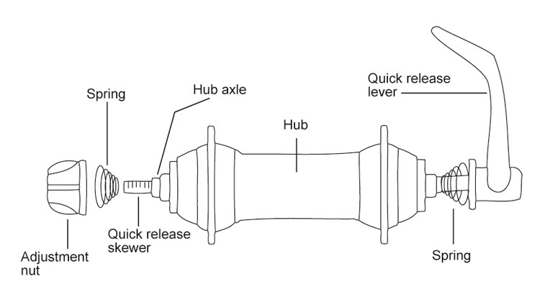 | 1. Locate and pull the wheel’s quick release lever | 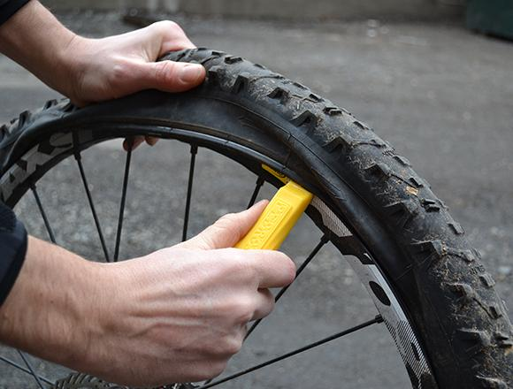 | 5. Pull lever down to remove edge of tire from rim
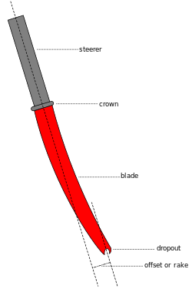 | 2. Pull the front wheel from the fork dropouts | 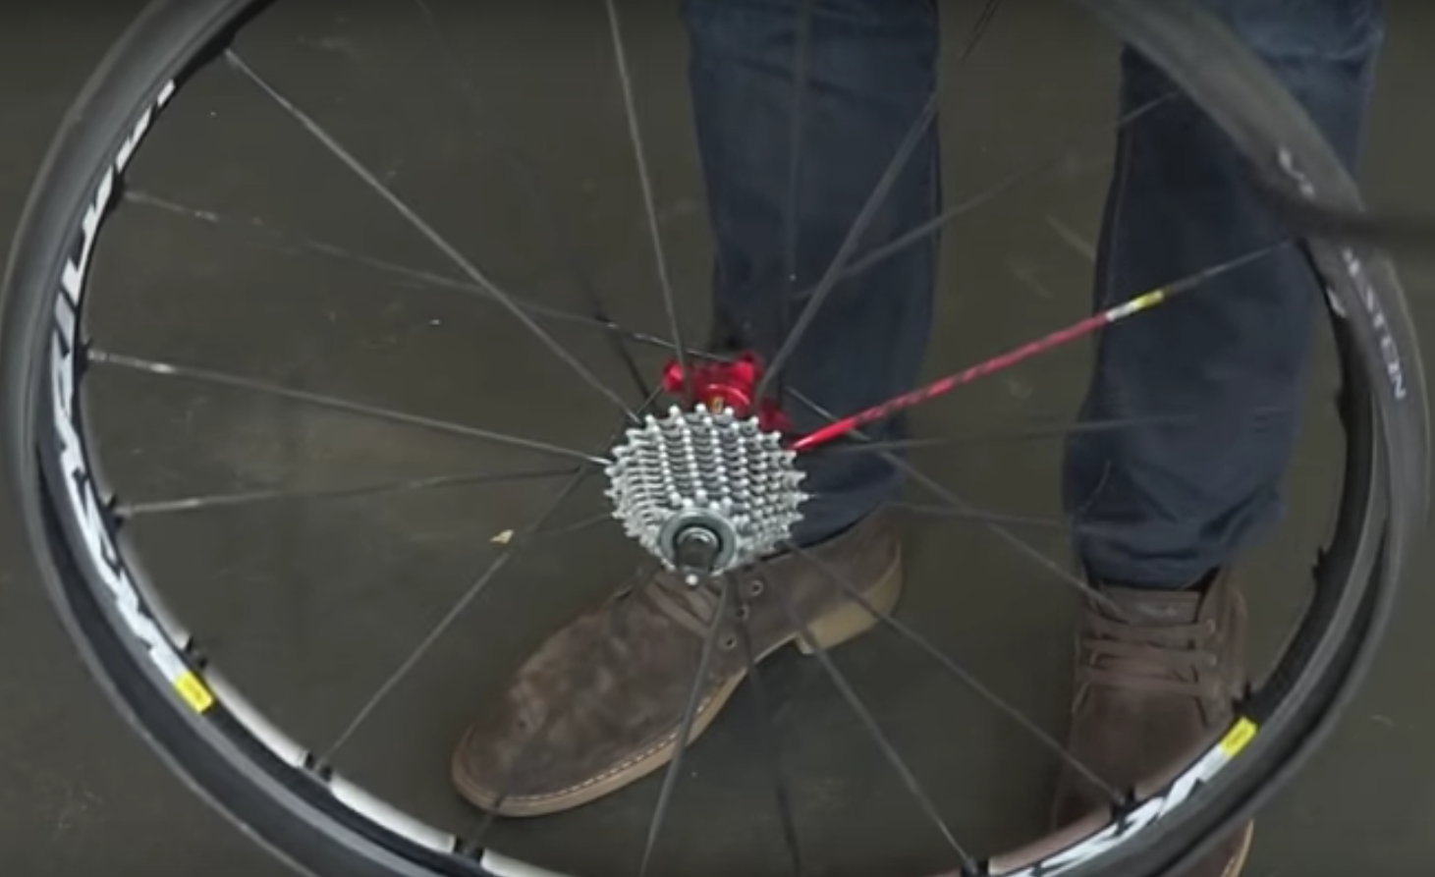 | 6. Slide tire lever along the rim to remove the first bead from the edge of the rim so it sits loose around the outer edge of the rim.
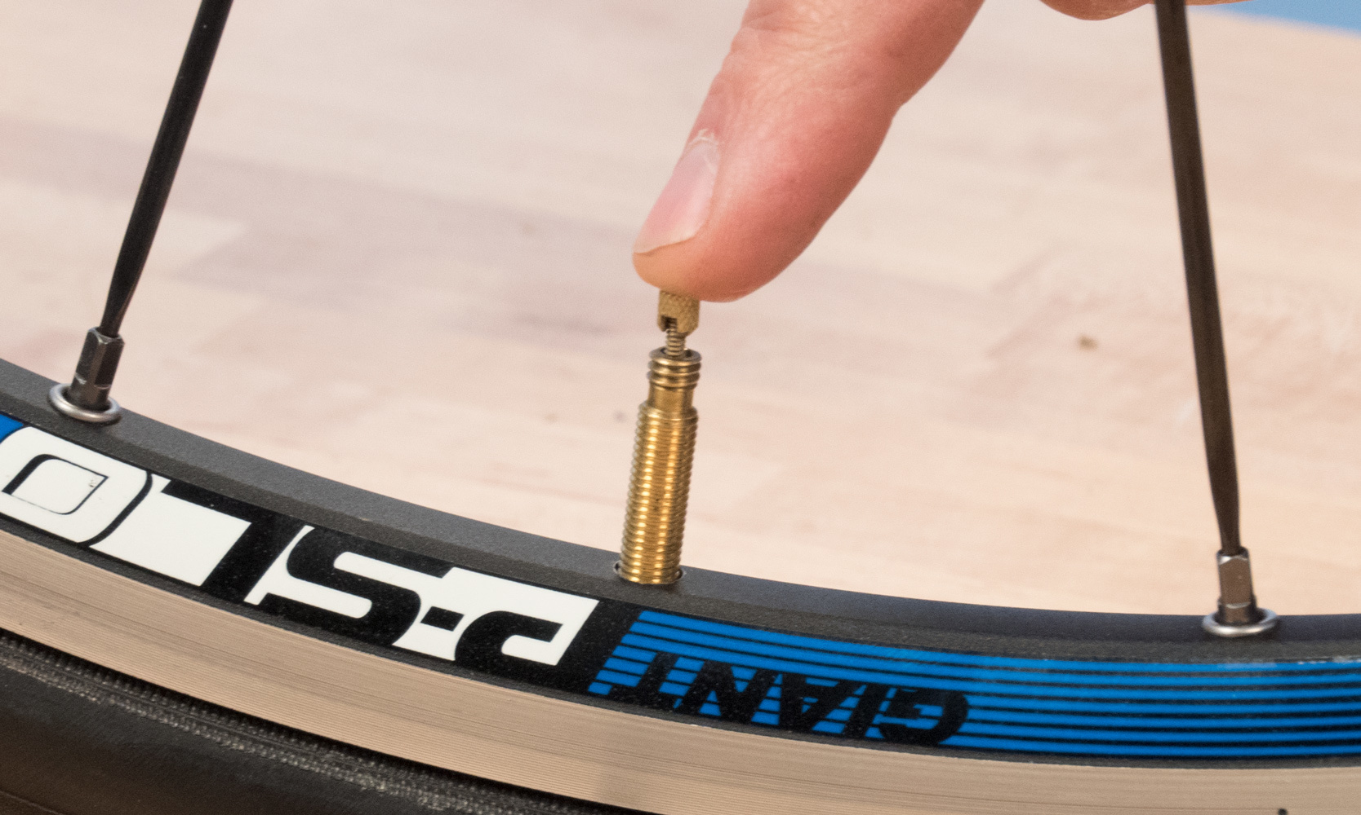 | 3. Unscrew the valve tip and press down to deflate the air from the tire | 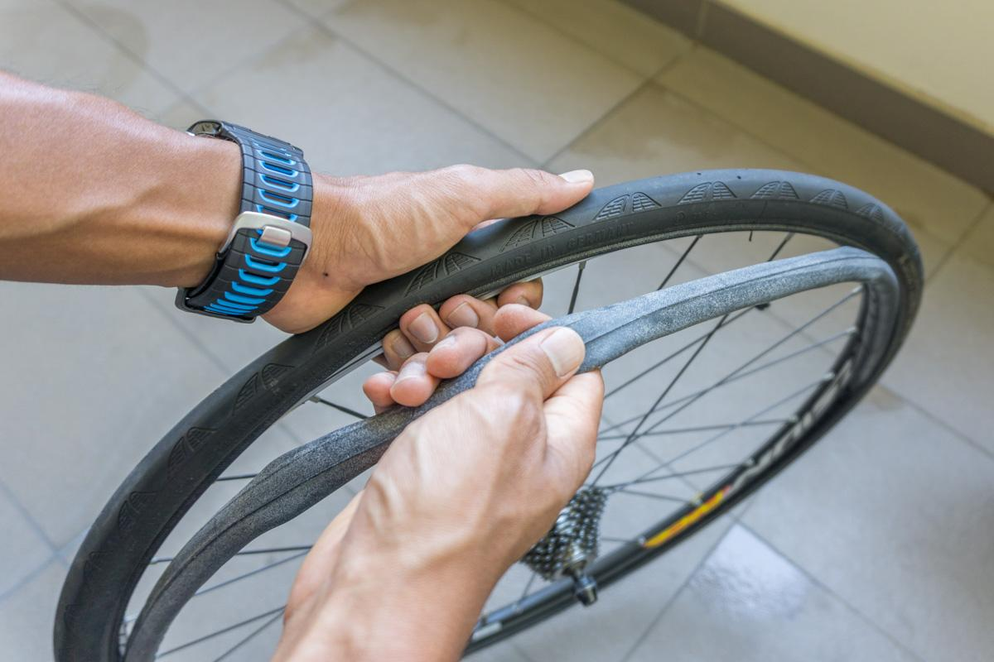 | 7. Remove the tube from the wheel and tire.
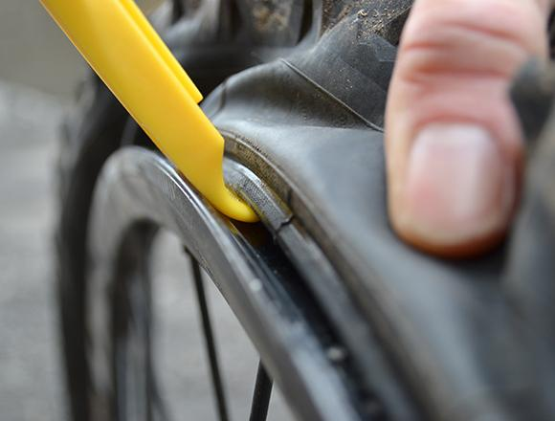 | 4. Inset tire lever under the edge (bead) of tire | 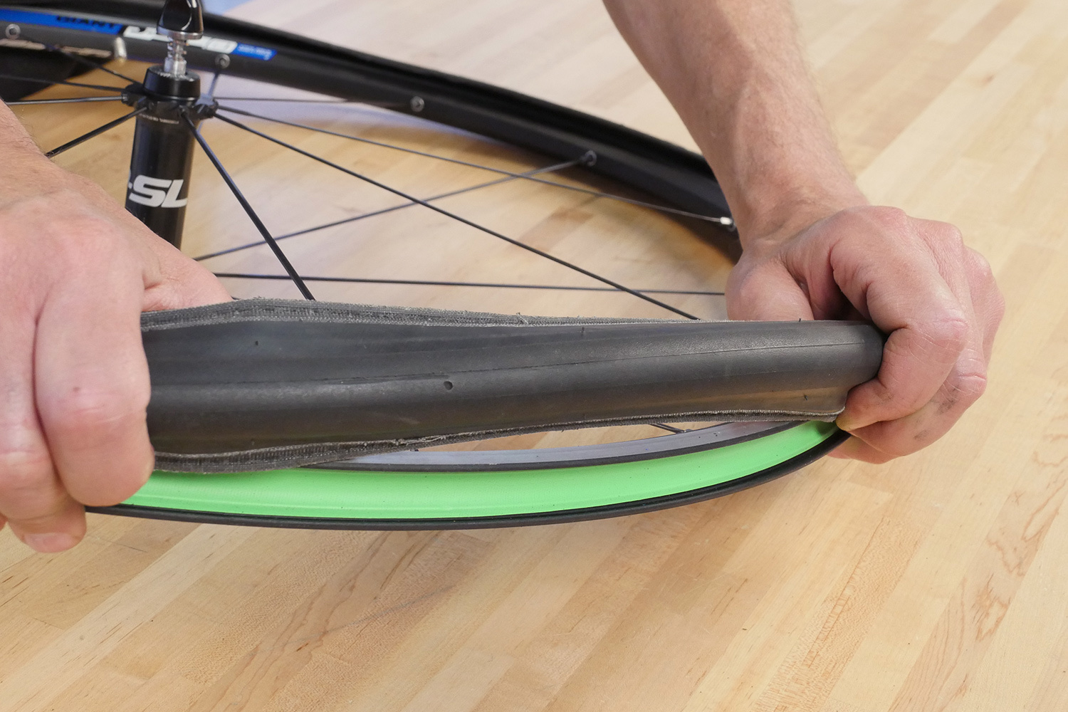 | 8. Pull the second half of the bead from the rim by hand

