*Assignment #3: “A Picture is Worth…” Visuals and Page Design*

General guidelines: You do not need to rewrite the question; **if the question asks for lists, use a list format, not paragraphs with commas. The following is a list format (which you should read).**

**Principle #1 in Professional Writing is using lists rather than paragraphs and long sentences.**

* Answers can be in phrases rather than sentences.
* You may also save this document and enter the answers in between the questions. This is not required, but is very helpful.
* Submit only one assignment per e-mail.
* You will receive a response that either says: “Assignment # __ complete OR
* If corrections are needed, they will be indicated in the response.
* Reply to the response with the corrections; do not create a new e-mail for the corrections.
* Make sure you watch the video lesson related to the assignment.

*For Questions 1 and 2, make sure you give* ***specific/detailed examples*** *which you learned in the previous assignment on Details (Assignment #2).*

1. a. Give a **specific** example of how a visual will assist with each of the following
   * What something looks like- Lodge Cast Iron Skillet-15 in.
   * 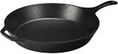
   * Makes your point clearer- Aquaman uses the Trident of Neptune
   * 

How processes work: Calvin Cycle in Photosynthesis.

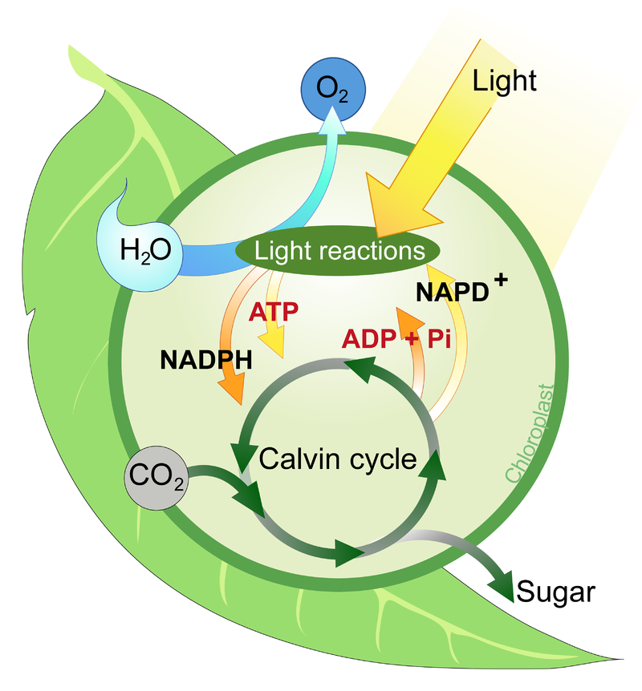

b. Give a **specific** example of how visuals:

* + Serve as a universal language- Everyone knows that when the sun is up it is daytime.
  + 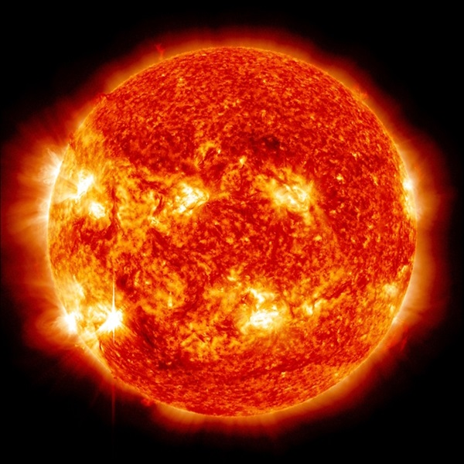
  + Make comparisons- Nike Phantom Vision Pro DF FG Firm Ground Soccer Cleat- Color: Black/Gold size 10
  + 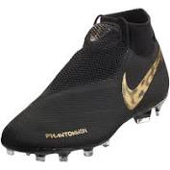
  + Nike Tanjun High-Rise Women’s shoes- Color Black/Black/Anthracite size 8.5 boys
  + 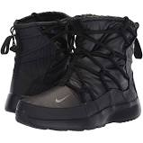

1. Give **specific** examples of each of the following types of visuals:

* Charts- Pie Chart
* 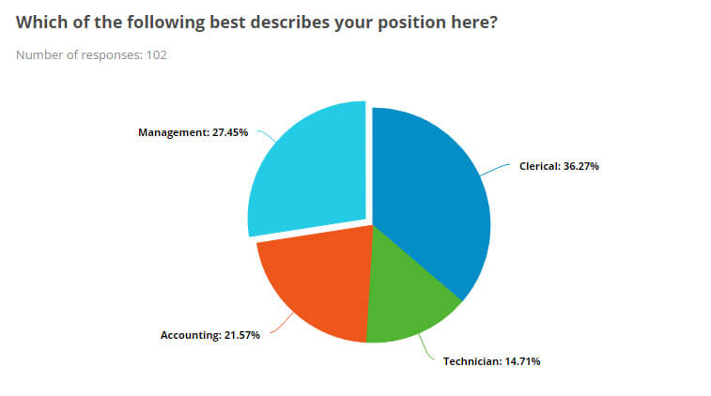
* Graphs- Bar Graph
* 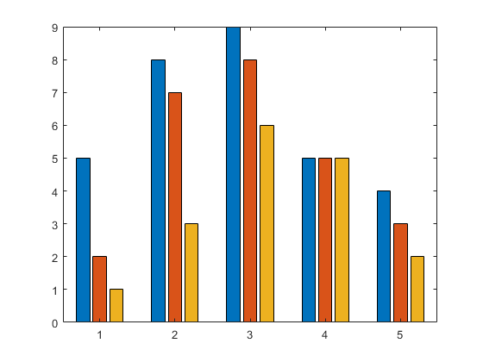
* Tables
* 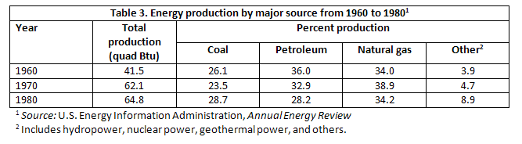
* Illustrations/Pictures
* 