#3: Details: There are three primary types of details (see the Class Notes section on details and the related video lesson)

* Definitions:

-Hobby: an activity that is done for fun on ones free time

-Cup: a round container used to hold liquid for drinking such as water

* Technical Descriptions:

1. Book: a bound set of paper with hand written or typed wor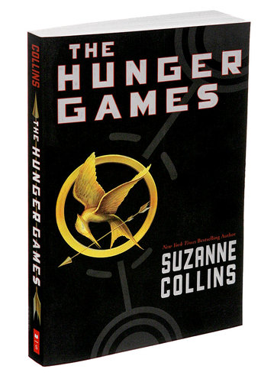ds to keep information or tell stories

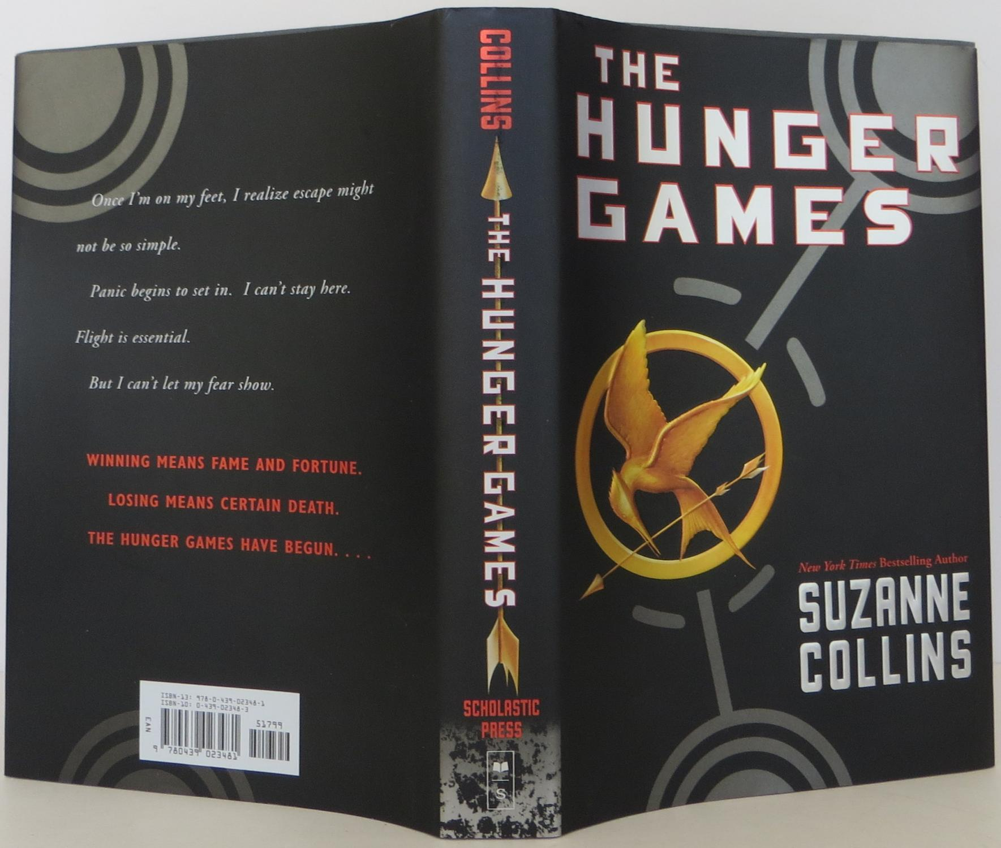

*Title: the name of the book

*Front Cover: protective cover of the front of the book

*Author: the writer of the book

*Spine: encloses the inner edges of the pages

*Back cover: protective covering of the back of the book

*Pages: many sheets of paper that have written or typed words

The covers of a book is used to provide both the name and author of the book as well as protection for the pages within. The pages inside the book have written words on them to be read by a reader to receive information from the book.

2. Compact Disk or CD: a circler plastic disk that stores digital information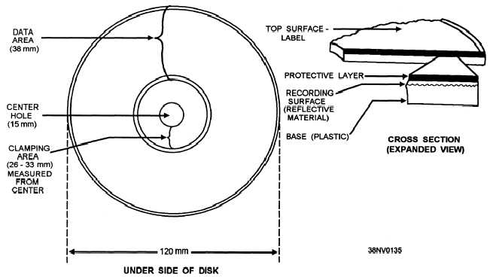

A CD works only with a device able to play it. This device is usually called a CD player but there are a variety of devices which can play CD’s such as gaming systems. Once a CD is inserted to a CD player then the device will begin to read the information on the shinning side of the disk using a very small laser. Once the information is read it goes to your screen or speakers where you can hear, see, or hear and see said information.

* Specifications:

1.**The Hunger Games (Book 1) Paperback**

Product Details

-Age Range: 12 and up

-Series: The Hunger Games (Book 1)

-Paperback: 384 pages

-Publisher: Scholastic Press; Reprint edition (July 3, 2010)

-Language: English

-Product Dimensions: 5.5 x 1 x 8.5 inches

-Weight: 11.2 ounces

2. **CD Album Queen Greatest Hits**

Product Details

-Original Release Date: November 3, 1981

-Release Date: May 14, 2007

-Label: Hollywood Records

-Copyright: PC 1992 Hollywood Records, Inc.

-Total Length: 58 minutes and 58 seconds

-Genres: Rock