A Comparative Analysis
of
The Effectiveness of Two Marvel Superheroes
Proposed for
The United States
Department of Defense

by

Jane Doe, Chief Analyst
Superheroes Unlimited

A Comparative Analysis
of
The Effectiveness of Two Marvel Superheroes
Proposed for
The United States
Department of Defense

for

United States Secretary of Defense
Defense Department
Washington, D.C.

by

Jane Doe, Chief Analyst
Superheroes Unlimited

March 15, 2019

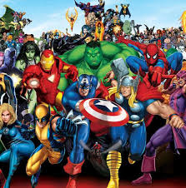
Superheroes Unlimited

12345 Sunset Creek
Palmer, Alaska 99645
Phone: (907) 255-5555

March 15, 2019

Patrick M. Shanahan
Acting Secretary of Defense
Department of Defense
1400 Defense Pentagon
Washington, DC 20301-1400

Dear Mr. Shanahan:

Attached is our report on the comparison of two marvel superheroes under consideration for hire for the Department of Defense. We appreciate that you chose Superheroes Unlimited to provide this report. I believe that you will find the report thorough and full of applicable data which will be relevant for the choice at hand.

We have enjoyed the opportunity to complete this report and stand by our recommendation that Thor, god of thunder, is the best candidate for the job. We have applied every test possible to determine which marvel superhero would be most effective in the defense of the nation. We’ve tried to take into account every angle that would be relevant to your decision process.

We are happy to provide this report and hope that you will send the check right away. Please call upon us for any consulting work that you might need in the future. Remember we have unlimited knowledge on all superheroes and would be pleased to assist with any analysis in the future.

Sincerely,

Jane Doe
Chief Analyst

TABLE OF CONTENTS

Page
LETTER OF TRANSMITTAL ii

ABSTRACT iv

INTRODUCTION 1

Background 1
Purpose of Report 2
Qualifications of Consultant 2
Data Sources 4
Scope and Limitations 5

COLLECTED DATA 5

Analysis of Thor, god of thunder 6
Laboratory Analysis (Natural Elements) 6
Laboratory Analysis (Skills) 6
Bystander/Observer Surveys 9
Review of Literature 9
Summary of Findings 10
Interpretation of Findings 10
Analysis of Captain America – Steve Rogers 11
Laboratory Analysis (Natural Elements) 11
Laboratory Analysis (Skills) 11
Bystander/Observer Surveys 14
Review of Literature 14
Summary of Findings 15
Interpretation of Findings 15

CONCLUSION AND RECOMMENDATIONS 16

Summary of Findings 16
Conclusions 16
Recommendation 17

APPENDIXES 18
Appendix A. Laboratory Testing (Natural Elements) 18
Appendix B. Laboratory Testing (Skills) 19
Appendix C. Sample Questionnaire 19
Appendix C. Internet Sources 21
Appendix D. Comparative Statistics 22

ABSTRACT
This report was prepared at the request of the United States Department of Defense because they have been seeking an objective analysis of the effectiveness of two marvel super heroes to hire one for the defense of the nation. Unknown threats and the many different climate conditions of the United States make it hard to choose one hero. An analysis was made of the top two heroes – Thor and Captain America – to recommend which hero should be selected by Department of Defense.

The analysis was conducted by laboratory testing (natural elements), laboratory testing (skills), by a review of the literature, and by a bystander/observer satisfaction survey. The following findings resulted from our analysis:
Findings Concerning Thor
- Thor’s strength is obviously his strength. Durability unsurprisingly comes along with the strength. His intelligence might be on the lower side when compared to fellow heroes but he makes up for it with speed and fighting skills. His total skill number is 29.
- Survey results are varied, but tend to be more positive than negative, based upon the fact that those taking the survey are still breathing. Thor’s ability to fly always provoked extra credit points in surveys.
- The literature reveals a variety of effects Thor has on people as well as options for further consideration in expanding the safety of the United States.
- Thor himself can withstand extreme heat, cold, and wind. Thus he is likely to fight well for you no matter what part of the United States he is asked to defend or what type of weather is occurring at the moment.
Findings Concerning Captain America
- Captain America’s strength is his fighting skills and friendly personality. His intelligence also makes him a valuable asset. His ability to assess a situation and think through the best way to defeat a threat with the least amount of damage is favored by many. His total skill number is 18.
- Survey results are varied, but tend to be more positive than negative, based upon the fact that those taking the survey are still breathing. Captain America’s positive attitude always helps to bring light to the dark times of attack.
- The literature reveals a variety of effects Captain America has on people as well as options for further consideration in expanding the safety of the United States.
- Captain America can withstand extreme heat, and cold. He isn’t affective in the wind. Thus he is likely to fight well the United States as long as the winds don’t exceed 100 miles per hour.

iv

The conclusions and recommendations follow:
Conclusions
• Both Thor and Captain America have fought for civilians everywhere. Both Thor and Captain America are attractive and would be great publicity for any nation.
•Although Captain America beats Thor in intelligence and speed, when it comes to efficiently fighting a threat, Thor’s strength, durability, and energy projection give him the edge.
•Thor is more efficient in defeating a threat.
•It is clear that Thor will keep more people alive and cause less damage to a city in the process, just saving the governement money.
•Consequently, both in terms of investment realistic defense, Thor is the better choice.
Recommendation
• The United States Department of Defense should select Thor to hire for the defense of the nation.

v

INTRODUCTION

Background

Keeping a country safe is very complicated in this day of superheroes and villains. The rate at which villains are coming out of the wood work, and cities are being terrorized and destroyed, has caused the Secretary of Defense to budget funds towards hiring one marvel superhero to protect the country. Preliminary research suggests that there are two candidates that could best single handedly handle the onslaught of evil that crops up out of nowhere. The Department of Defense has contracted with our firm to provide a detailed analysis of each superhero and to recommend which one should ultimately be chosen for the benefit of all. Since this is a major financial undertaking and all our lives literally depend on the success of this venture, thorough research analysis and investigation is extremely important. Consequently, the exhaustiveness and complexity of the analysis is critical to ensure that the best decision is made based upon exemplary research.

Each of these superheroes has been used by other countries, but none have been hired by a government for full time protection before.

The two superheroes which are being reviewed and analyzed in this study are:

- Thor Odinson – Prince of Asgard, god of thunder
Figure 1: Thor in Action

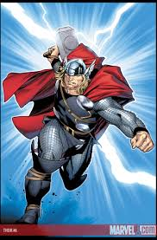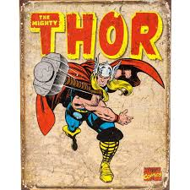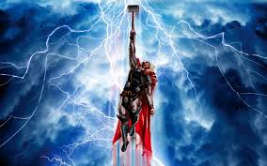

- Captain America – Steve Rogers, New York
Figure 2: Captain America in Action

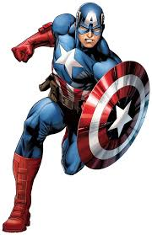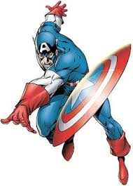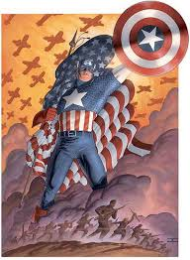
1

Purpose of Report

The purpose of this report is to study, analyze, and research the qualities and characteristics of two superheroes – Thor and Captain America – to determine which superhero should be selected by the Department of Defense to help protect the nation from evil villains. Additional determinates may be made for long range planning for the safety of the whole world. The report is prepared for Secretary of Defense for use in both the immediate and long-term planning efforts.

Qualifications of Consultant

Superheroes Unlimited started in business in 2008 when Iron Man flew into the lives and hearts of many. During the last decade the company has fallen in love with all the superheroes who have emerged to save the day and destroy evil. We have followed, interviewed, and some would even say stalked our way into the lives of these beloved good guys getting all the inside scoop on their skills, weapons, strengths, and dare we say it, weaknesses as well. If there is something you need to know about a superhero, we are the ones to come to. The Department of Defense should have complete confidence in our ability to provide the requested analysis since our staff have been avid fans and groupies or the heroes for years.

The executive management of our consulting firm includes the following:

 Vivan Ward, Chief Executive Officer
•Experience includes beauty, brains, and uncanny ability to make men fall for her
•Utilizes God given assets to get the information needed
•Graduated from High Stakes University with a degree in management
•Works with brawns, brains, and idiots

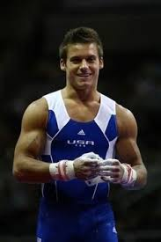 Chris Shaper, Chief Operations Officer
•Experience includes fighting of all types including cat
•Graduated from University of Martial Arts, majoring in gold management
•Speaks Russian & English equally well
•Has a positive, winning, disarming smile

2

Sheldon, Sherry, Chief of Creative Analysis
•Experience with theory’s, and big word
•Works behind the scenes on literally everything
•Has a master’s in Chemistry, Biology, Physics, and Engineering from Cambridge
•Tends to offend frequently creating fabulous survey/testing results

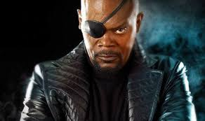Nick Fury, Chairman of the Board
•Known for his ability to know everything about superheroes
•Former Chief Executive of Spy in Disguise
•Tends to do everything his way
•No university training but the school of hard knocks has taught him much

Many of the rest of unique staff are pictured below. They know how to get the right stuff.
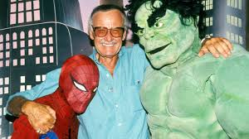

A complete listing of all the employees who work for Superheroes Unlimited can be obtained from our website: www.weknowyourhero.net. Additionally, our company keeps other consultants on retainer for special cases. For example, an entire sorority at the University of New York was recruited to show the results of being distracted by a super hero in action. The research obtained from that chaos group made it possible to recommend not hiring the most attractive hero due to massive loss of life. A side finding of that study indicated that a superheroes presence in an area actually drew civilians to a danger zone. One cannot help the stupidity of humanity, but they can endeavor to protect it.

3

Data Sources

In order to provide a proper analysis, it was critical to research all of the information related to the products in question before beginning with our standard investigative processes.
The literature and other research related to shredding have been thoroughly investigated. Our company prides itself on being up to date in chair making technology. The staff attends annual conferences and seminars on the latest methods for constructing, testing, and demolition of chairs. Our sources of information were several and varied. They include:

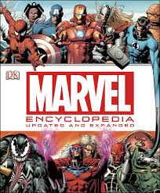 •Marvel Encyclopedia: An extensive documentary in word form on all things marvel.

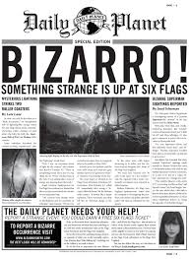•Daily Planet: A reliable source on all things hero

•Comic Con: A national conference attended only by experts in the field of power

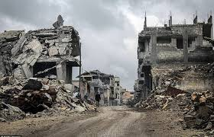 •Stop the destruction: Governmental publications which deal with the reality of damaged caused from the heroes fighting for our lives.

A thorough review of the sources at hand made it possible for superheroes unlimited to begin the analysis without repeating research which had already been conducted. Additionally, it allowed us to establish a framework to provide the parameters for our research while focusing on the relevant aspects of a superhero’s pros and cons in regard to protecting a city.

4

Scope and Limitations

The following report will provide results related to testing all throughout the country. Since this report is being provided for the Department of Defense, the analysis will focus on the ability of the two marvel superheroes ability to defend an area.

The report is written exclusively for the Department of Defense and is not intended to offer conclusions for any other nation. The report is copyrighted and thus cannot be reproduced in any way, shape or form without the written consent of the Chief Executive Officer of Superheroes Unlimited as well as the two superheroes in question.

The report is being produced for the government so it may become classified. In that case, Superheroes Unlimited asks that no one come in and destroy all of our data and hard won research and facts. We will willingly black out all necessary portions of the report.

This report and analysis should be replicated every six months as heroes are emerging constantly, and the threat at hand might be better dealt with by a fresh set of muscles and power. It is important that research not die as many of us will if the right candidate isn’t chosen for the job.

COLLECTED DATA

An analysis was made of the qualities and characteristics of Thor using the standard analytical techniques which are unique to Superheroes unlimited. Captain America was then analyzed in a parallel manner. Findings, interpretation of findings, and conclusions were developed for each hero. An overall recommendation will then be made concerning which marvel hero should be selected by the Department of Defense for the safety of us all.

Each marvel hero, Thor and Captain America, were analyzed separately using the following techniques:
•Laboratory Analysis (Natural Elements)
•Laboratory Testing (Skills)
•Bystander/Observer Surveys
•Research of Specialized Literature

Findings and interpretation of findings are provided for each of the following criteria:
•Strength & Durability
•Intelligence
•Speed
•Fighting Skill
•Energy Projection
• Effectiveness Survey

5
Analysis of Thor

•Laboratory Analysis:

Thor was tested under all weather conditions. Extreme cold weather conditions down to
-1000° F, and extreme heat conditions up to 1000° F. These conditions were achieved by placing the hero in a lab where we were able to imitate the environments of different planets where these temperatures are common place. Thor did not freeze in place until the lab reached -900°. Thor’s hammer stuck to his armor however at -700°. He was still able to slowly swing his arms up until he froze in place. The extreme cold did not affect his heart which kept beating strongly throughout the whole process. The extreme heat did not kill Thor either. However, he kept slipping on his own sweat.

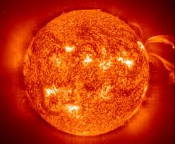

Thor was also tested under extreme wind in desert conditions as that is a possibility in several parts of the United States. Winds up to 200 miles per hour were procured in our state of the art testing lab. The sand blowing all around made it difficult for Thor to see anything, however he was able to fly with the winds holding out his hammer pretending to fight villains.

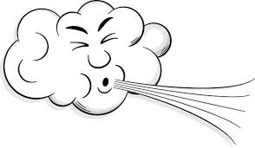

The specific details of these experiments are contained in Appendix A of this report.

•Laboratory Testing (Skills):
Laboratory Testing (Skills) was carried out again at our amazing lab. In this case the hero was tested in six main categories: speed, intelligence, fighting skills, durability, strength, and energy projection. The tests were repeated every day for a month to make sure there were no outlying factors and everything was as accurate as possible.

Speed- Testing a hero’s speed can’t be done with a stopwatch because some of them move too quick for the human eye to catch. That’s why our state of the art lab is equipped with a running room. In our running room we can test sprints as well as speed over a long period of time. For effectively defending a city we decided that overall speed throughout

6.
several hours was the best way to go. There are several levels with different scenery so our heroes don’t get bored.



Intelligence- This assessment was done through book smarts and street smarts. The hero took the SATs an ACTs every morning. In the afternoon there were several different role play scenarios to see whether the hero fell for the robots tricks or out smarted them, and whether they could separate the innocent from the guilty.

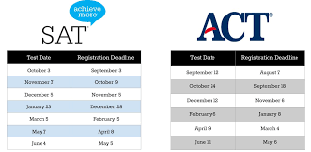

Fighting Skills- Our custom built robots were put to use here. Each hero faced different fighting styles, different abilities, and strengths. Each day they fought robots we through something different at them to see their fighting skills in action.

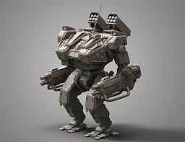

Durability- Assessed during the fighting skills stage. How well did the hero stand up to the robots? How well did they do after hours and hours and weeks of fighting?



7.
Strength- Yes, we did have the heroes bench press for us. We just wanted at least one simple straight forward test.



Energy projection- Don’t try and asses this skill at home folks. Thanks to our amazing lab and the technology we have there we are able to calculate this using a highly detailed and complex calculation that the human brain can’t comprehend. If I put the formula here your brain would explode so I’ll save us all the mess and just tell you it’s impressive.



During all tests, electrodes were attached to the bodies of the heroes. The electrodes measured heart rate, brain activity, and even the mood of the hero. The results were measured to determine if we were pushing the heroes overboard or making them go crazy. After compiling all our data we put it together in the following graph making it easy for the everyday joe blow to understand the results of the tests.

The specific details of these experiments are contained in Appendix B of this report.

8.
•Bystander/Observer Surveys:
Bystander satisfaction surveys were sent to each Governor of a state where Thor had previously fought in as well as each governing official in any other part of the world where Thor had fought. The survey document contained 15 questions. Our researched showed that the fewer the questions, and the more direct they were, the more we were able to get 100% completion and accuracy. A copy of the survey form is found in Appendix C.
Because we are superheroes unlimited the survey response rate was 99%. Unsurprising since everyone wants to have a superhero they can count on, on their good side.

The summary findings in the rated areas are shown on the following graph:

•Review of Specialized Literature:
A research of the available articles about Thor provided the following articles:

- "Man or god, Does it Even Matter,” from The Best this World Has to Offer, by Killer Jones.
The article expresses the notion that the "only thing that matters is saving our butts”
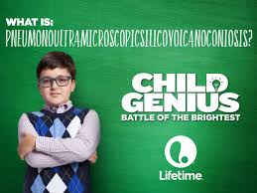Mr. Jones
- "More SideKicks,” from The SideKick Movement, by Robin Boy.
The article suggests that Thor will be more effective in the defense of the world if he had a paid side kick accompanying him.

9.
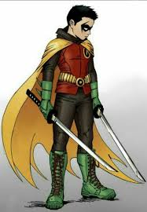Mr. Boy
- "Hero – Love him, Hate him,” from What Women Want, What Men Don’t, by Jamie Smith
The article notes that men and women have different reactions to Thor appearing on the scene. Women tend to stare uncontrollable or faint which tends to provoke hostile feelings towards Thor in the men they are with.

Mr. Smith

Further sources of information can be found in Appendix D.

•Findings Concerning Thor
- Thor’s strength is obviously his strength. Durability unsurprisingly comes along with the strength. His intelligence might be on the lower side when compared to fellow heroes but he makes up for it with speed and fighting skills. His total skill number is 29.
- Survey results are varied, but tend to be more positive than negative, based upon the fact that those taking the survey are still breathing. Thor’s ability to fly always provoked extra credit points in surveys.
- The literature reveals a variety of effects Thor has on people as well as options for further consideration in expanding the safety of the United States.
- Thor himself can withstand extreme heat, cold, and wind. Thus he is likely to fight well for you no matter what part of the United States he is asked to defend or what type of weather is occurring at the moment.

•Interpretation of Findings Concerning Thor

The United States Department of Defense should be aware of initial high cost, which can be amortized over time. Thor will literally outlive us all. He might make a few mistakes but he specializes in destroying evil. Thor might cause some destruction while defending a city, make a few illogical choices, and distract a few citizens with his good looks, but in the end the price is well worth the cost. The surveys indicated that girls favored Thor over other heroes such as the Hulk.

10.
Analysis of Captain America

•Laboratory Analysis:

Captain America was tested under all weather conditions. Extreme cold weather conditions down to -1000° F, and extreme heat conditions up to 1000° F. These conditions were achieved by placing the hero in a lab where we were able to imitate the environments of different planets where these temperatures are common place. Captain America did not freeze in place until the lab reached -850°. Captain America’s shield never froze to his suit. He was able to wink up until -850°. The extreme cold did not affect his heart which kept beating strongly throughout the whole process. The extreme heat did not kill Captain America either. Captain America did not slip on his sweat, instead he used it to easily slide around.

Captain America was also tested under extreme wind in desert conditions as that is a possibility in several parts of the United States. Winds up to 200 miles per hour were procured in our state of the art testing lab. The sand blowing all around made it difficult for Captain America to see anything. He used his shield to protect his face from the wind but he was pinned against the wall unable to move through the winds once they reached the speed of 100 miles per hour.

The specific details of these experiments are contained in Appendix A of this report.

•Laboratory Testing (Skills):

Laboratory Testing (Skills) was carried out again at our amazing lab. In this case the hero was tested in six main categories: speed, intelligence, fighting skills, durability, strength, and energy projection. The tests were repeated every day for a month to make sure there were no outlying factors and everything was as accurate as possible.

11.
Speed- Testing a hero’s speed can’t be done with a stopwatch because some of them move too quick for the human eye to catch. That’s why our state of the art lab is equipped with a running room. In our running room we can test sprints as well as speed over a long period of time. For effectively defending a city we decided that overall speed throughout several hours was the best way to go. There are several levels with different scenery so our heroes don’t get bored.

Intelligence- This assessment was done through book smarts and street smarts. The hero took the SATs an ACTs every morning. In the afternoon there were several different role play scenarios to see whether the hero fell for the robots tricks or out smarted them, and whether they could separate the innocent from the guilty.

Fighting Skills- Our custom built robots were put to use here. Each hero faced different fighting styles, different abilities, and strengths. Each day they fought robots we through something different at them to see their fighting skills in action.

Durability- Assessed during the fighting skills stage. How well did the hero stand up to the robots? How well did they do after hours and hours and weeks of fighting?

12.
Strength- Yes, we did have the heroes bench press for us. We just wanted at least one simple straight forward test.

Energy projection- Don’t try and asses this skill at home folks. Thanks to our amazing lab and the technology we have there we are able to calculate this using a highly detailed and complex calculation that the human brain can’t comprehend. If I put the formula here your brain would explode so I’ll save us all the mess and just tell you it’s impressive.

During all tests, electrodes were attached to the bodies of the heroes. The electrodes measured heart rate, brain activity, and even the mood of the hero. The results were measured to determine if we were pushing the heroes overboard or making them go crazy. After compiling all our data we put it together in the following graph making it easy for the everyday joe blow to understand the results of the tests.

The specific details of our robots can be found in Appendix B of this report.

13.
•Bystander/Observer Surveys:
Bystander satisfaction surveys were sent to each Governor of a state where Captain America had previously fought in as well as each governing official in any other part of the world where Captain America had fought. The survey document contained 15 questions. Our researched showed that the fewer the questions, and the more direct they were, the more we were able to get 100% completion and accuracy. A copy of the survey form is found in Appendix C. Because we are superheroes unlimited the survey response rate was 99%. Unsurprising since everyone wants to have a superhero they can count on, on their good side.

The summary findings in the rated areas are shown on the following graph:

•Review of Specialized Literature:
A research of the available articles about Captain America provided the following articles:

- "Man or god, Does it Even Matter,” from The Best this World Has to Offer, by Killer Jones.
The article expresses the notion that the "only thing that matters is saving our butts”
Mr. Jones
- "More SideKicks,” from The SideKick Movement, by Robin Boy.
The article suggests that Captain America will be more effective in the defense of the world if he had a paid side kick accompanying him.

14.
Mr. Boy
- "Hero – Love him, Hate him,” from What Women Want, What Men Don’t, by Jamie Smith
The article notes that men and women have different reactions to Captain America appearing on the scene. Women tend to stare uncontrollable or faint which tends to provoke hostile feelings towards Captain America in the men they are with.

Mr. Smith

Further sources of information can be found in Appendix D.

•Findings Concerning Captain America
- Captain America’s strength is his fighting skills and friendly personality. His intelligence also makes him a valuable asset. His ability to assess a situation and think through the best way to defeat a threat with the least amount of damage is favored by many. His total skill number is 18.
- Survey results are varied, but tend to be more positive than negative, based upon the fact that those taking the survey are still breathing. Captain America’s positive attitude always helps to bring light to the dark times of attack.
- The literature reveals a variety of effects Captain America has on people as well as options for further consideration in expanding the safety of the United States.
- Captain America can withstand extreme heat, and cold. He isn’t affective in the wind. Thus he is likely to fight well the United States as long as the winds don’t exceed 100 miles per hour.

•Interpretation of Findings Concerning Captain America

The United States Department of Defense should be aware that the intelligence and fighting skills of Captain America are an asset but can only go so far. Although Cap can see what needs to be done, he might not have the speed or the strength to do it himself. Surveys revealed that although Captain American was not prideful and was friendly, the cost of rebuilding a city after he’s been assigned to protecting it was higher than most bottom lines. Everyone enjoys the appearance of Captain America

15.
CONCLUSIONS AND RECOMMENDATIONS

•Summary of Findings

The findings are summarized by the charts below:

Further statistics are found in Appendix D.

•Conclusions

Both Thor and Captain America have fought for civilians everywhere. Both Thor and Captain America are attractive and would be great publicity for any nation. They are friendly and talented. Thor, however, is more efficient in defeating a threat. Thus, saving money because less of a city is destroyed the quicker an enemy is defeated. Captain America beats Thor in intelligence and speed but when it comes to fighting a threat Thor’s strenth, durability, and energy projection give him the edge. Thor doesn’t have to come up with genius plans, he just needs to be able to destroy the enemy and leave the plans to someone else.

16.
•Recommendation

The United States Department of Defense should select Thor to hire for the defense of the nation.

17.
Appendix A: Laboratory Testing Procedures (Natural Elements)
Note: Due to the sensitive nature of these reports and the horrible possibility of a villain using our findings against our marvel superheroes, these procedures will appear invisible to everyone unless they know the key words to speak making them visible for a time. The key words are constantly changing for added protection. Contact Merlin for authorization if needed. (Just say his name three times and he’ll come to you)

Methods

Lab Construction Preparation
Knowing we must test each hero in extreme circumstances, our team procured only the best materials to construct our superhero testing lab. The best scientific minds in the marvel hero community created the plans from scratch. Then our other super hero connections (unnamed for their protection) procured all the necessary elements from the far reaches of space to build our state of the art lab. Construction was tricky due to the nature of the testing that needed to take place but with the help of many friends and skilled professionals of course, we were able to build a lab capable of withstanding anything we could throw at it. The heroes themselves might die but literally the lab will NEVER be destroyed. We did that good of a job.

Heat procurement, Specificity
In order to achieve the extreme heat situations in which to test superheroes, superheroes unlimited sent the Phoenix into the sun to procure some of it for us. Don’t worry it’s in a patented protection box (we can’t reveal all our secrets), and we’re able to slowly open the state of the art door system to allow the heat from the sun to permeate the testing room until desired temperature at which point the door is slowly closed again. If you sunburn easily, we recommend you stay away from our lab as the heat rays tend to go through walls even if the heat stays in the lab.

Cold procurement, Specificity
Of course, the frost giants helped us out here. It pays to know people in all places. Even Loki can be helpful if given the right incentive. Knowing Thor could possibly freeze in the extreme cold made him very happy to be our lead specialist on the case. He procured the coldest cold there is from his home planet and managed to create a device for us to utilize this cold in our lab. Do we think this could eventually back fire on us someday? Why yes, it’s Loki we’re dealing with, so of course we have come up with many contingent possibilities to make sure the cold can never leave the lab.

Wind procurement, Specificity
Gathering the winds speeds necessary was a bit trickery than expected. Our break through finally came after the Flash sped by our facility. After training for several weeks he was finally able to run fast enough to create winds up to 200 miles per hour. With Merlin and other unnamed pros we were able to leash the winds. Now we’re able to let them out and bind them back up again at will. Let me say you don’t want to get caught in this wind storm.

18.

Limits
The state of the art lab is amazing but it is not limitless. It does not have the capacity to test the heroes fighting abilities under water. However if the world is underwater, we’ll all be dead and the results won’t matter.
Appendix B: Laboratory Testing Procedures (Skills)
Note: Due to the sensitive nature of these reports and the horrible possibility of a villain using our findings against our marvel superheroes, these procedures will appear invisible to everyone unless they know the key words to speak making them visible for a time. The key words are constantly changing for added protection. Contact Merlin for authorization if needed. (Just say his name three times and he’ll come to you)

Robot Experts

Our amazing in house staff built robots from scratch to specially withstand (to the best of our scientific ability) the extreme weather conditions our heroes were tested under. Their fighting skills were downloaded from Fight For Your Life, the leaders on the latest and best fighting programs right at your fingertips.

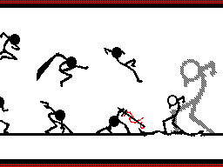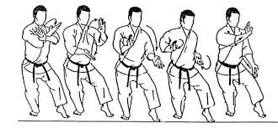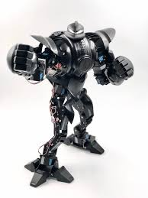

636 × 295
The lab is able to have the heroes face off against 1-1000 robots at any given time. For variety’s sake all the robots are completely different in skill and size. Thus the heroes must constantly be on their guard never knowing what to expect from their opponent.

Appendix C: Sample Questionnaire

The questionnaire below is specifically designed to assess how effect a superhero was in a previous battle.

- How well did the hero defeat the threat?
  - Completely obliterate it
  - Drive it away (temporarily)
  - He/she didn’t defeat the threat

19.
- How much damage was done in your city from the threat? Choose closest %
  - 10%
  - 30%
  - 50%
  - 80%

- How much damage was done in your city because of the hero? Chose closest %
  - 10%
  - 30%
  - 50%
  - 80%

- How much of your city was destroyed by both threat and hero?
  - 20%
  - 50%
  - 80%
  - 100%

- Would you want the said hero to defend your city again?
  - Yes
  - No
  - Maybe

- How many lives were lost in attack?
  - 0 – 10
  - 10 – 20
  - 20 – 30
  - 30 – 40
  - 40 or more

- How much time did the hero spend receiving praise from the citizens?
  - 10 minutes
  - None
  - A half an hour
  - Several hours

- Was the hero good looking?
  - Yes
  - No

- Did the hero’s looks distract civilians, placing them in danger?
  - Yes
  - No

- Did the hero need a weapon to defeat the threat?
  - Yes
  - No, the hero used only his powers

20.
- Did the hero listen to those in charge?
  - We never spoke to the hero
  - Yes
  - No

- Was the hero respectful of the laws of the land?
  - Yes
  - No
  - We don’t know
  - We’re too scared to tell the hero they broke a law

- Please describe in detail the pros of the super hero that protected you.

- Please describe in detail the cons of the super hero that fought for you.

- How much did it or will it cost to rebuild your city?

Appendix D: Internet Sources
Again, these sources are protected and require proper incantations to decode.

World’s Connected
Oak, Janet. "How many planets are there and what can we really expect?" <http://planet.universe/history/world_history/archives/gods>. June 2009.

Fly Site
Man, Super <100303.100@compuserve.com>. "Take to the Skies: Escape 101." <abc.de.fgh.ij> [path: fly/local/FLYINTERNATIONAL/continent/.txt]. August 2018.

Strength Site
"How to Strength Muscles." <biceps.quads.com> [Path: Work Out More/Civic & Historical/Body Builders R-US.]. 25 May 1800.

Help Group Messages
Georgia, Fox <weseeyou@hurting.com>. " Scream Louder (ScreamCatchingSpyWare)." In <scream.scream.scream>. 5 January 1999.
Icy Ewe <vision@seefarther.org>. "Psychic101." In <checkyoureyes>. 5 October 1999. Archived at: <http://www.eye.see.vision.uk/look/farther/please/telesope/amplify-faq."> http://www.eye.see.vision.uk/look/farther/please/telesope/amplify >.

21.

E-mail Messages
Gossip, Girl <sally@tellall.com>."Latest and Greatest on all things heroes." Private e-mail message to Gossip Girl from anyone who catches site of any hero doing anything. 1 January 2000.

Appendix E: Comparative Statistics :

22.

23.

