*For Questions 1 and 2, make sure you give* ***specific/detailed examples*** *which you learned in the previous assignment on Details (Assignment #2).*

1. a. Give a **specific** example of how a visual will assist with each of the following
   * What something looks like

**If you were trying to describe what a moose looked like, it would be easiest to use a picture such as the one below.**

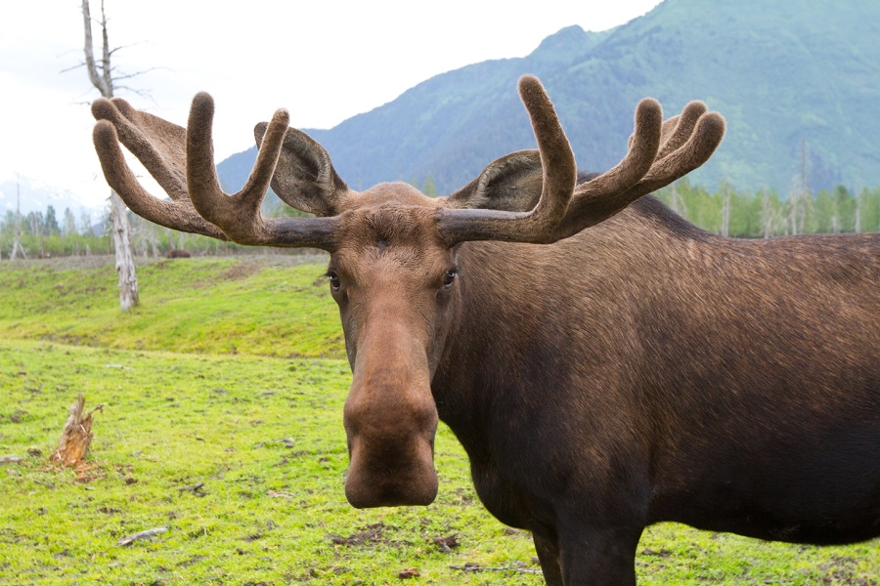

* + Makes your point clearer

**If you were trying to prove that plants will grow the most leaves when they are exposed to constant light, you could use a graph such as the one below.**

* + How processes work

**If you were trying to explain the process of how a plant grows, you could use a diagram such as the one below.**

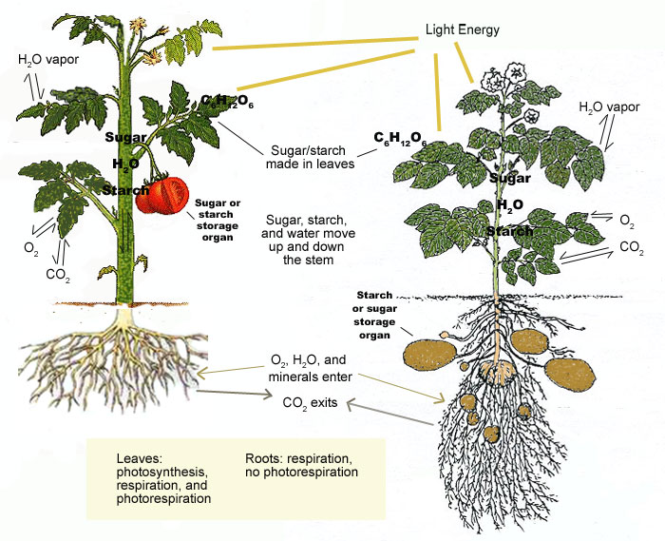

b. Give a **specific** example of how visuals:

* + Serve as a universal language

**Visuals serve as a universal language. No matter what language a person speaks, a picture can be easily understood. A good example is a bathroom sign. No matter where you are in the world, most of the time you can find the bathroom because of pictures.**

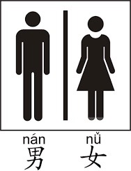

* + Make comparisons

**Visuals help people see the differences when you are comparing two or more things. Below is a chart comparing the calorie difference between chocolate chip cookies and peanut butter cookies.**

1. Give **specific** examples of each of the following types of visuals:

* Charts
* Graphs
* Tables

|  |  |  |
| --- | --- | --- |
| Cups | Tablespoons | Teaspoons |
| 1 C | 16 | 48 |
| ¾ C | 12 | 36 |
| ½ C | 8 | 24 |
| 1/3 C | 5 | 15 |

* Illustrations/Pictures

