*For Questions 1 and 2, make sure you give* ***specific/detailed examples*** *which you learned in the previous assignment on Details (Assignment #2).*

1. a. Give a **specific** example of how a visual will assist with each of the following
   * What something looks like

A airplane that is sitting on a runway at an airport

Description generated with high confidence

* + Makes your point clearer

A close up of a map

Description generated with high confidence

* + How processes workA close up of a flower

    Description generated with high confidence

b. Give a **specific** example of how visuals:

* + Serve as a universal language

A red stop sign

Description generated with very high confidence

* + Make comparisons

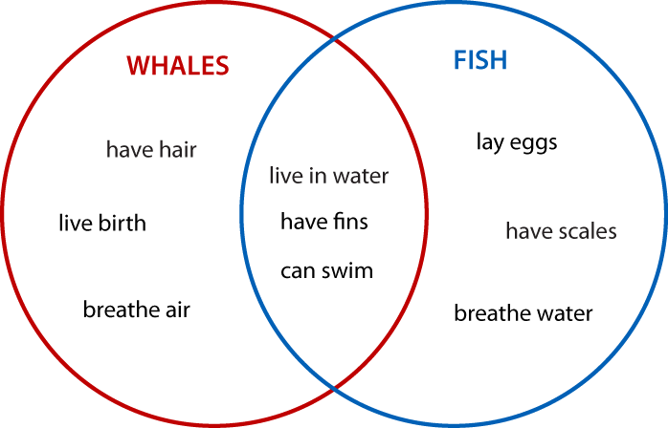

1. Give **specific** examples of each of the following types of visuals:

ChartsA close up of a map

Description generated with very high confidence

* Graphs

A screenshot of a cell phone

Description generated with very high confidence

* Tables

A close up of a device

Description generated with high confidence

* Illustrations/Pictures

A close up of a map

Description generated with very high confidence