*For Questions 1 and 2, make sure you give* ***specific/detailed examples*** *which you learned in the previous assignment on Details (Assignment #2).*

1. a. Give a **specific** example of how a visual will assist with each of the following
   * What something looks like

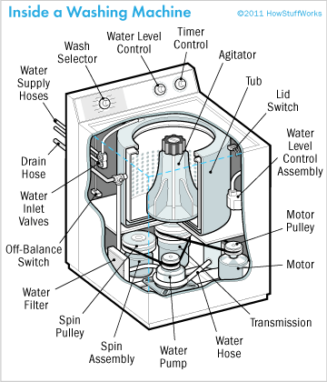

* + Makes your point clearer

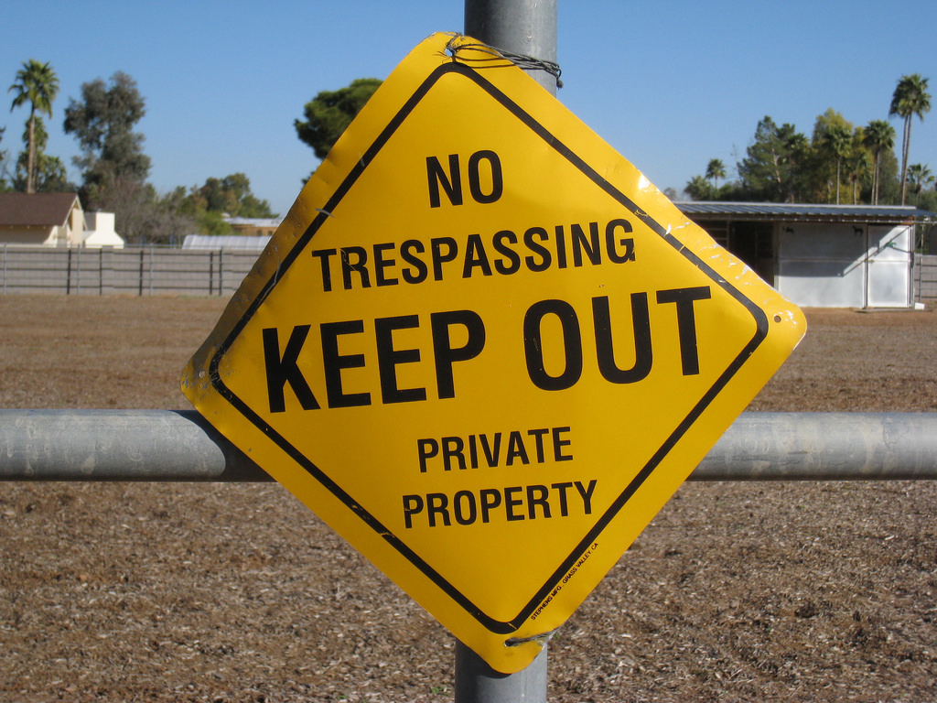

[This Photo](https://www.flickr.com/photos/athomeinscottsdale/3279949186) by Unknown Author is licensed under [CC BY](https://creativecommons.org/licenses/by/3.0/)

* + How processes work

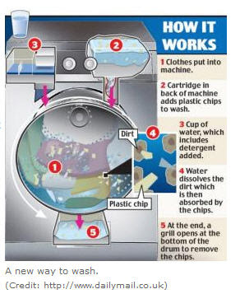

[This Photo](http://www.tslr.net/2008_06_01_archive.html) by Unknown Author is licensed under [CC BY-SA-NC](https://creativecommons.org/licenses/by-nc-sa/3.0/)

b. Give a **specific** example of how visuals:

* + Serve as a universal language



[This Photo](http://www.ipharmd.net/symbol/medical_cross/red_cross_round_red.html) by Unknown Author is licensed under [CC BY-NC-ND](https://creativecommons.org/licenses/by-nc-nd/3.0/)

* + Make comparisons

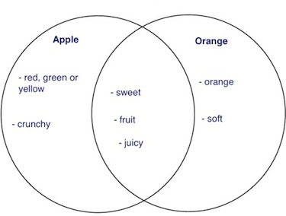

[This Photo](http://busybrainsatsea.blogspot.com/2012/02/venn-diagramswhale-sharks.html) by Unknown Author is licensed under [CC BY-NC-ND](https://creativecommons.org/licenses/by-nc-nd/3.0/)

1. Give **specific** examples of each of the following types of visuals:

* Charts – pie chart

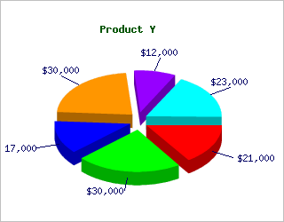

[This Photo](http://stackoverflow.com/questions/2794504/difference-between-chart-plot-and-graph) by Unknown Author is licensed under [CC BY-SA](https://creativecommons.org/licenses/by-sa/3.0/)

* Graphs – bar graph

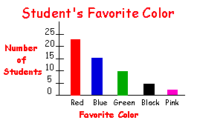

[This Photo](http://spmath81411.blogspot.com/2011/11/jeremys-graphing-post.html) by Unknown Author is licensed under [CC BY-NC](https://creativecommons.org/licenses/by-nc/3.0/)

* Tables – Periodic Table of Elements

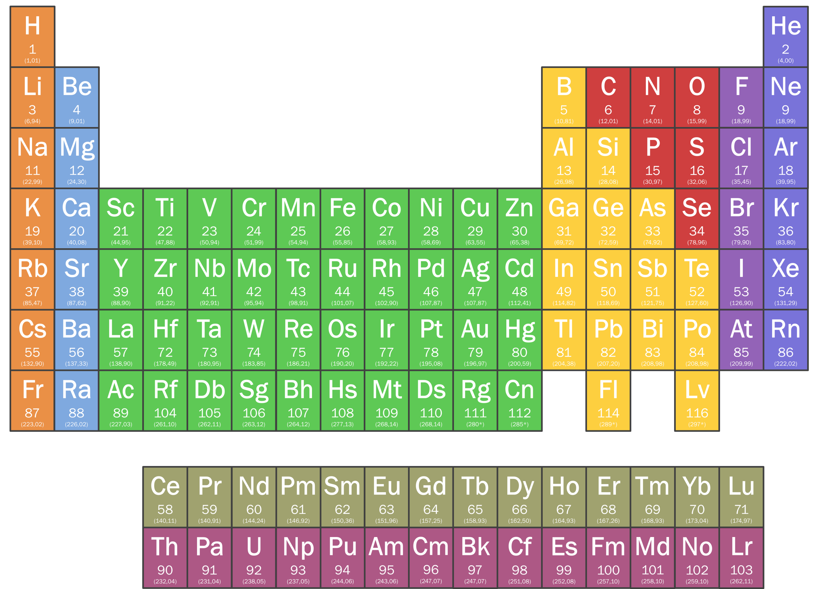

[This Photo](http://nl.wikipedia.org/wiki/Bestand:Periodic_Table.png) by Unknown Author is licensed under [CC BY-SA](https://creativecommons.org/licenses/by-sa/3.0/)

* Illustrations/Pictures – a map

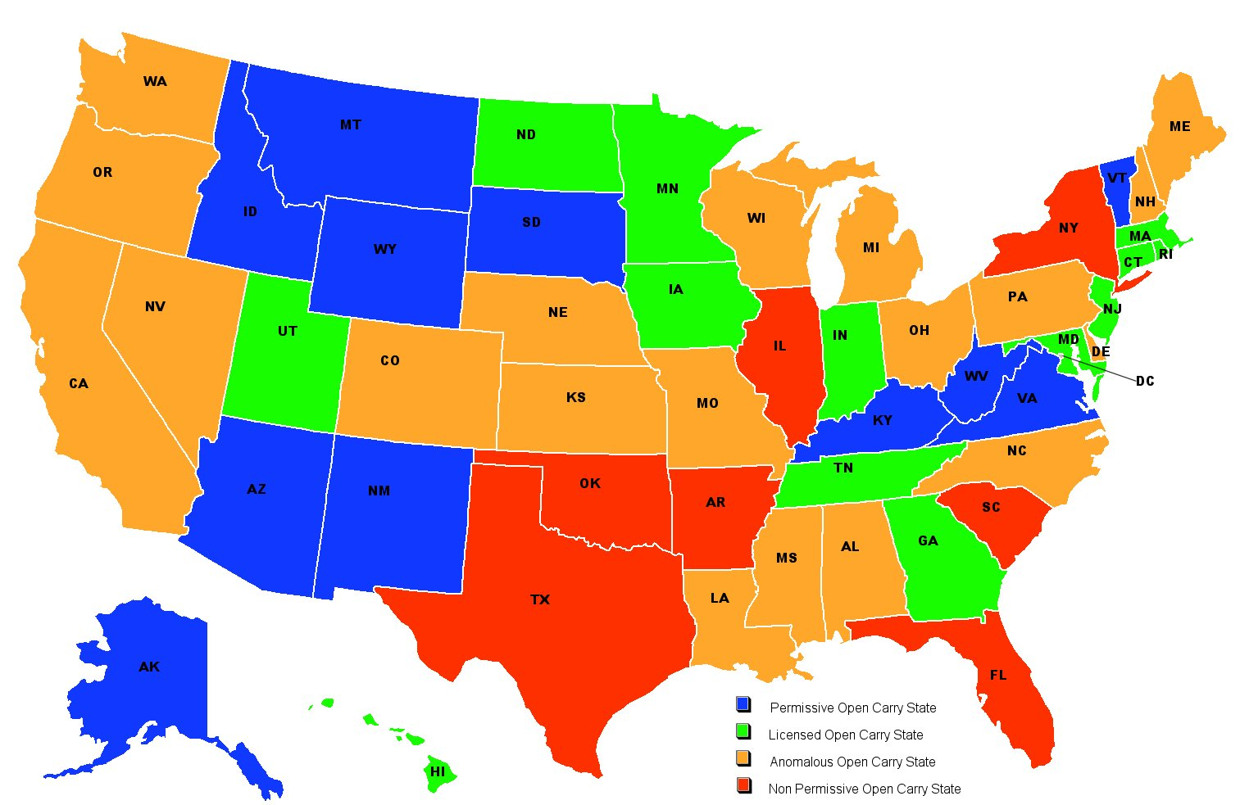

[This Photo](http://en.wikipedia.org/wiki/File:USA_Carry_Map.jpg) by Unknown Author is licensed under [CC BY-SA](https://creativecommons.org/licenses/by-sa/3.0/)