**•Technical Descriptions**

**(#1)** <https://biggreenegg.com/egg-works/>

**[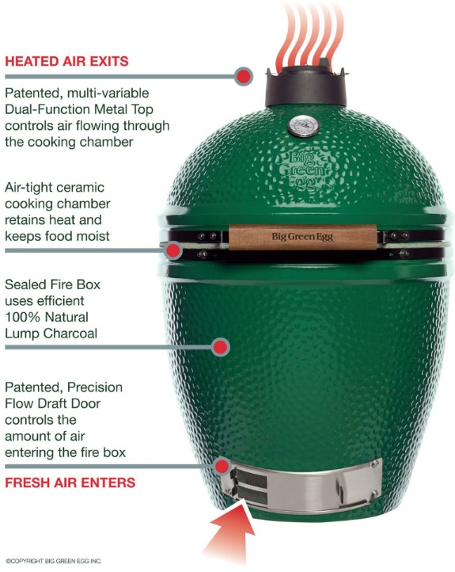](https://biggreenegg.com/wp-content/uploads/2015/06/how-the-egg-works-HiRes.jpg)**

**Simple to Start**

The Big Green Egg reaches perfect cooking temperature and is ready to use in just minutes. Our 100% lump charcoal is made in the USA from only the best cuts of natural oak and hickory for superb performance and results. Lighting the charcoal is always quick and easy, as the design of the Big Green Egg allows air flow to circulate efficiently. Use our natural charcoal starter or an electric starter … and never buy lighter fluid again!

**Precise Temperature Control**

Grill, smoke and bake on your EGG at exact temperatures by easily adjusting the patented air flow systems. You have total control over temperature at your fingertips, maintaining accuracy within a few degrees! The Made in USA temperature gauge provides precise readings to 750°F/ 400°C. Many indoor ovens cannot match the accuracy of the EGG’s temperature control!

**(#2)** [**https://www.mne.psu.edu/cimbala/me345/Lectures/How_the_iPhone_Works.pdf**](https://www.mne.psu.edu/cimbala/me345/Lectures/How_the_iPhone_Works.pdf)

**[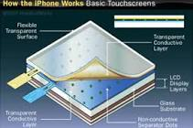](https://www.google.com/imgres?imgurl=https://s.hswstatic.com/gif/iphone-rev-1.jpg&imgrefurl=https://electronics.howstuffworks.com/iphone1.htm&h=240&w=360&tbnid=Fuiq0mCWBBfZuM:&q=how+an+iphone+works&tbnh=140&tbnw=211&usg=AFrqEzcYuzGYtAd2QdlIA59_JkNWVo1rEg&vet=1&docid=i4b4l4FkmjxpSM&hl=en&sa=X&sqi=2&ved=2ahUKEwig14-xnPjcAhWGK3wKHcDpAD8Q9QEwAHoECAQQBg)**

How the **iPhone Works**. The conductive layers in the **iPhone's** touch screen enable users to give the device commands with a simple swipe of the finger. ... Capacitive touch screens use a layer of capacitive material to hold an electrical charge; touching the screen changes the amount of charge at a specific point of contact.

**•Specifications**

**(#1)** [**https://www.gsmarena.com/apple_iphone_8-8573.php**](https://www.gsmarena.com/apple_iphone_8-8573.php)

[Apple iPhone 8
MORE PICTURES](https://www.gsmarena.com/apple_iphone_8-pictures-8573.php)

|  |  |  |
| --- | --- | --- |
| Body | [**Dimensions**](https://www.gsmarena.com/apple_iphone_8-8573.php) | 138.4 x 67.3 x 7.3 mm (5.45 x 2.65 x 0.29 in) |
| [**Weight**](https://www.gsmarena.com/apple_iphone_8-8573.php) | 148 g (5.22 oz) |
| [**Build**](https://www.gsmarena.com/glossary.php3?term=build) | Front/back glass, aluminum frame |
| [**SIM**](https://www.gsmarena.com/glossary.php3?term=sim) | Nano-SIM |
|  | - IP67 dust/water resistant (up to 1m for 30 mins) - Apple Pay (Visa, MasterCard, AMEX certified) |

|  |  |  |
| --- | --- | --- |
| Display | [**Type**](https://www.gsmarena.com/glossary.php3?term=display-type) | LED-backlit IPS LCD, capacitive touchscreen, 16M colors |
| [**Size**](https://www.gsmarena.com/apple_iphone_8-8573.php) | 4.7 inches, 60.9 cm2 (~65.4% screen-to-body ratio) |
| [**Resolution**](https://www.gsmarena.com/glossary.php3?term=resolution) | 750 x 1334 pixels, 16:9 ratio (~326 ppi density) |
| [**Multitouch**](https://www.gsmarena.com/glossary.php3?term=multitouch) | Yes |
| [**Protection**](https://www.gsmarena.com/glossary.php3?term=screen-protection) | Ion-strengthened glass, oleophobic coating |
|  | - Wide color gamut display - 3D Touch display & home button - True-tone display |

|  |  |
| --- | --- |
|  |  |
|  |  |  |
|  |  |  |
|  |  |  |
|  |  |  |

## **(#2)** [**http://biggreenegghead.com/big-green-egg/product-information**](http://biggreenegghead.com/big-green-egg/product-information%20%20%20%20%20%20%20%20%20%20%20%20%20%20%20%20%20%20%20%20%20%20%20%20%20%20%20%20%20) **Anatomy of the Egg**

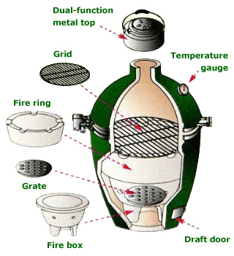

**The Big Green Egg Sizes**

There are 5 models of The Big Green Egg. For most people, I recommend the medium or large size. When deciding on an Egg, keep in mind that you can cook a little food on a large Egg, but you cannot cook a large amount of food on a small or mini Egg. Also, if you can afford it, don’t choose a smaller size simply because it is cheaper. It is very common for people to purchase a smaller Egg, only to decide they need to purchase a larger size within months of owning it. In fact, many Eggheads own 3 or 4 Eggs! Regarding fuel-efficiency, size does not have a major impact on charcoal consumption, and even the large Eggs can burn for hours with very little charcoal.

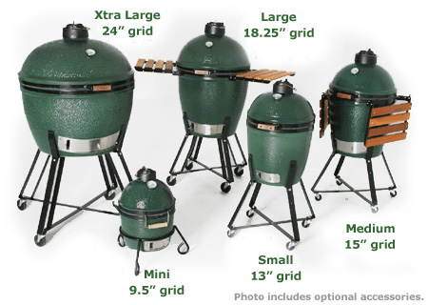

**Big Green Egg Dimensions**

| **model** | **grill diameter** | **height** | **width** | **weight** | **turkey capacity** |
| --- | --- | --- | --- | --- | --- |
| **Extra Large** | 24" | 27 ¼" | 26 ½" | 205 lbs. |  |
| **Large** | 18 ¼" | 30" | 21" | 140 lbs. |  |
| **Medium** | 15" | 26" | 18" | 95 lbs. |  |
| **Small** | 13" | 22" | 16" | 65 lbs. |  |
| **Mini** | 9.5" | 15" | 12" | 30 lbs. |  |