* Definitions
  + #1- Cast Iron Skillet

PRODUCT FEATURES

* Sturdy cast-iron construction
* Pre-seasoned surface for effortless food release
* Excellent heat retention
* Even heating for uniform cooking
* Ergonomic handle for easy lifting
* Use at home in on the oven, in the stove on the grill or over a campfire

PRODUCT CONSTRUCTION & CARE

* Cast iron
* Hand Wash. Dry immediately to prevent rusting.
* Oven safe up to 500°F
  + #2 -Bike rack Flexzion Bike Rear Rack Mount - Bicycle Back Seat Pannier Luggage Backpack Cargo Basket Carrier with Taillight Mount Lightweight Aluminum for Road MTB Mountain Folding Bike 55 lbs Capacity
    - A durable, versatile bike cargo rack for long distance touring. Mounts to the back of your bicycle to help you easily transport for strap-attached bags, panniers, luggage, backpacks, cargo, baskets, and etc
    - Material made of 6061 Hollow Aluminum, durable, lightweight, good quality. It?s easier to install and adjust thanks to flexible attachment arms and more than an inch of wheel clearance
    - The three rack stays design makes it stronger and more stable than racks with only two stays, and its maximum rated capacity of 55 pounds. It's fully welded for superior durability. This design makes it physically stronger and more stable under heavy loads
    - Well-made Redlite mounts are integrated into the platform which does double duty as a fender to protect you from road spray, and the rack ships with quality mounting hardware. Bolted-on piece of metal includes stainless steel mounting hardware throughout, and the included nuts are locking nuts which absorb road vibration and stay screwed
    - Fits almost bikes such as road bike, MTB mountain bike, folding bike fat bike and etc. but not suitable for rear suspension bike
* Technical Descriptions
  + #1-Flashlight

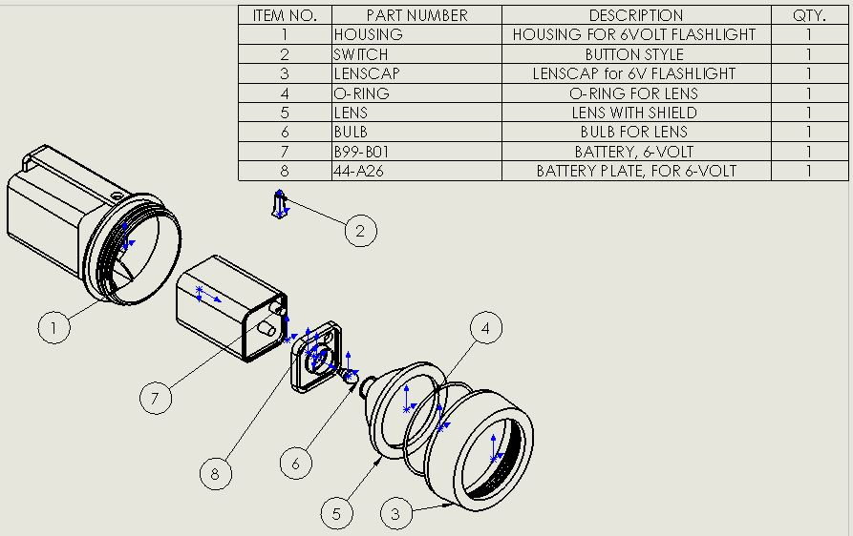

* + #2- Technical description of Television Sensor Assembly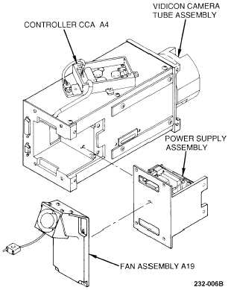
* Specifications:
  + **#1-Specifications of Whirlpool 1.4 Cu. Ft. Over the Range Microwave Oven**
* **Dimensions/Weight**
* **Exterior Dimensions (WxHxD):**
* 29 15/16" x 16 1/4" x 15 3/8"
* **Cavity Dimensions (WxHxD):**
* 22 3/8" x 8 3/16" x 13 13/16"
* **Approximate Shipping Weight (lbs.):**
* 58
* **Microwave**
* **Capacity (cu. ft.):**
* 1.4
* **Cooking Power (watts):**
* 950
* **Cooking Functions**
* **Auto Cooking:**
* Yes
* **Programmed Cooking:**
* 3-Stage
* **Variable Power Levels:**
* 10
* **Add Minute:**
* Yes
* **Cycles:**
* Dinner Plate, Pizza Reheat, Frozen Entree, Defrost, Reheat, Cook, Popcorn, Vegetable, Casserole, Baked Potato
* **Convenience**
* **Glass Turntable:**
* Sunken, Stoppable
* **Child Lockout:**
* Yes
* **Hood**
* **Exhaust Fan:**
* 2-Speed
* **EZ-Vue Cooktop Lighting:**
* Yes
* **Grease and Charcoal Filters:**
* Included
* **General Information**
* **Convertible for Vented or Non-Vented Use:**
* Yes
  + #2- iPhone 8

|  |  |
| --- | --- |
|  | **Apple iPhone 8** |
| Screen | 4.7-inch Retina HD IPS LCD |
| Resolution | 1,334 × 750 pixels |
| OS | iOS 11 |
| Storage | 64/256GB |