3: Details: There are three primary types of details (see the Class Notes and video lesson – there is also a specific document about Details under the Resources tab on the website:

* Definitions

**Moose-** the large mammal and member of the deer family that resides in North America.

**Pizza-** a round, flat piece of dough that has sauce spread over the top with sprinkled cheese on top. Other various toppings may be added. After the toppings are put on, the dough gets placed in the oven and baked.

* Technical Descriptions

**Product descriptions:**

**Apple-** a commonly eaten fruit that is part of the rose family.

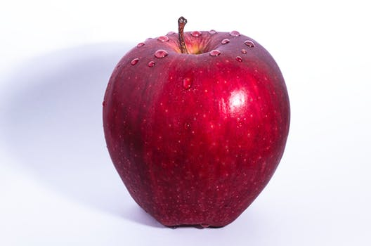

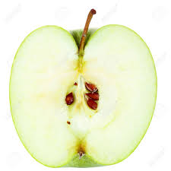

**Stem**

**Skin**

The tough outside covering to the apple.

**Flesh**

The inner soft part of the apple which we consume.

**Core**

The part of the that is tough and contains the seeds.

**Seeds**

The stem of the apple is the part that attached it to the tree before it was picked. The skin of the apple can be left on, or removed. When eating the apple raw, the skin is usually left on.

The flesh is the part of the apple that is consumed. The core protects the seeds in the center of the apple. The seed’s main function is to reproduce.

Apples are used throughout the world for a variety of different dishes or just eaten how they are.

**Light Bulb-** a glass bulb that passes and electrical current through a filament, producing light.

**Glass Bulb**

**Tungsten Filament**

Part of the lightbulb that produces light.

**Support Wires**

**Contact Wires**

Connect the filament to the main electrical source.

**Cap**

**Electrical Contact**

Transfers electricity from main source to the bulb.

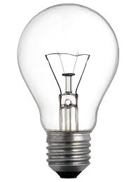

The glass bulb provides support for the other parts of the lightbulb. The tungsten filament is the part of the light bulb that actually produces light. The support wires hold up the tungsten filament. Contact wires transfer the energy from the main electrical source to the tungsten filament. The cap is the part of the light bulb that is attached the main electrical source. The electrical contact is where the current is transferred from.

In practically every home in America is lighted by lightbulbs. These incredible inventions have been around for a while, but many improvements have been made to them since their invention.

* Specifications

**Carson 6-qt. Mixer Specifications**

|  |
| --- |
| **General** |
| Capacity 6-qt. |
| Color Blue |
| Manufacturer Carson Manufacturers |
|  |
| **Dimensions/ Weight** |
| Height 16 in. |
| Width 9 in. |
| Weight 25 lbs. |
|  |
| **Motor** |
| Power Consumption 900 |
| Number of Speeds 7 |
|  |
| **Accessories** |
| 1 set cookie dough paddles |
| 1 blender attachment |
| 1 dough hook |

**Eskimo Refrigerator Specifications**

|  |
| --- |
| **General** |
| Capacity 17 (cu. ft.) |
| Color Dark Blue |
|  |
| **Dimensions/ Weight** |
| Height 68 in. |
| Width 45 in. |
| Depth 35 in. |
| Weight 310 lbs. |
|  |
| **Features** |
| Water Dispenser 1 |
| Interior Lights 4 |
| Humidity Controllers 2 |